Rainforest Worksheet – World Book Student
Did you know that scientists estimate that rainforests in the Daintree have existed for about 180 million years? Learn more about rainforests on World Book Online.
Go to http://www.worldbookonline.com
Click on “Student.” If prompted, log on with ID and password

Since this activity is about Rainforest, you can start by searching the key word “Rainforest.”
All the answers can be found in the Rainforest encyclopedia article.

1. What are the two major types of rainforests? ______________________________________________________________________________
2. Tropical rainforests are found near Earth’s equator, between which two imaginary lines?
______________________________________________________________________________
3. Where are tropical rainforests found?
______________________________________________________________________________
4. What are two ways rainforests benefit the planet?
(1) ___________________________________________________________________________
(2) ___________________________________________________________________________
5. What are two ways rainforest benefit people?
(1) ___________________________________________________________________________
(2) ___________________________________________________________________________
Scroll down to Characteristics of rain forests/Climate and answer the question below.
6. What is the definition of a tropical rainforest?
______________________________________________________________________________
Scroll down to Characteristics of rain forests/Structure and growth and answer the questions below.
7. In the layers of the rainforest, what are the tallest trees called that rise above the canopy?
______________________________________________________________________________
8. What is the layer called that forms a nearly continuous cover of a rainforest? ______________________________________________________________________________
9. What is the shady area called below the canopy where shade-tolerant hardwoods grow?
______________________________________________________________________________
10. What is the lower treetop level of a rainforest called?
______________________________________________________________________________
Scroll down to Characteristics of rain forests /Plant life and answer the questions below.
11. What plant group plays a major role in rainforests, some growing to more than 20 metres?
______________________________________________________________________________
12. More kinds of this flowering plant (monocots) grow in the rainforest than any other type of plant? ________________________________________________________________________
Scroll down to Characteristics of rain forests/Animals and answer the question below.
13. Watch the Animals of tropical forests video to find the answer.
What animal species make up the largest single group of animals that live in tropical forests? ______________________________________________________________________________
Scroll down to Rain forests around the world and answer the questions below.
14. The Amazon Rainforest stretches nearly the width of which continent?
______________________________________________________________________________
15. The tropical rainforests of Africa are home to which two unique animals?
______________________________________________________________________________
16. Where are Australia’s tropical rainforests located?
______________________________________________________________________________
Scroll down to Rain forests and people/Native cultures and answer the question below.
17. What group of people have lived in Southeast Asian rainforests for centuries?
______________________________________________________________________________
Scroll down to Rain forests and people/Threats to rain forests and answer the question below.
18. List two reasons for damage or destruction of rainforests and give an example.
(1) ___________________________________________________________________________
______________________________________________________________________________
(2) ___________________________________________________________________________
______________________________________________________________________________

Scroll down to Rain forests and people/Saving rain forests and answer the question below.
19. List three ways governments and organisations are working to conserve rainforests.
(1) ___________________________________________________________________________
______________________________________________________________________________
(2) ___________________________________________________________________________
______________________________________________________________________________
(3) ___________________________________________________________________________
______________________________________________________________________________
Click on the Images, Videos, and Audio tab and click on Rain forests of the world map
20. Colour the area where rainforests are located on the world map:
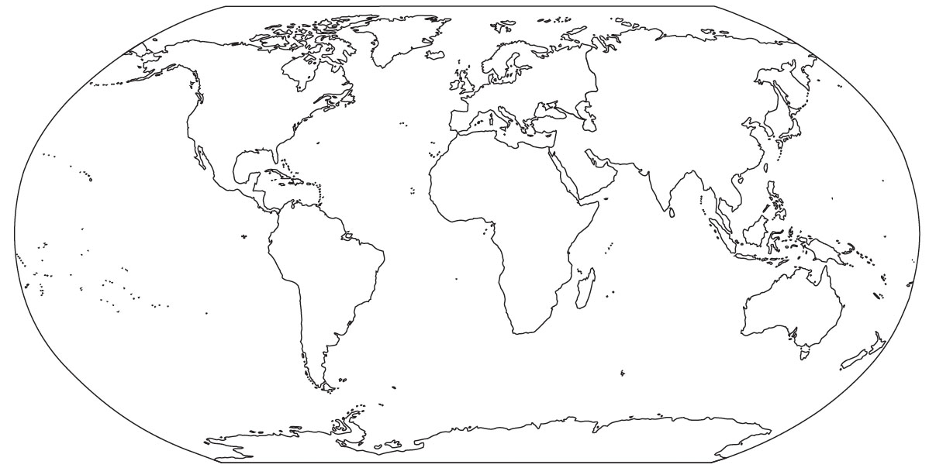

Learn More!
- Click here to read more about the Amazon rainforest.
https://www.worldbookonline.com/student/article?id=ar015850

- Click here to learn more about the Daintree rainforest in northeast Australia.
https://www.worldbookonline.com/student/article?id=ar755859

