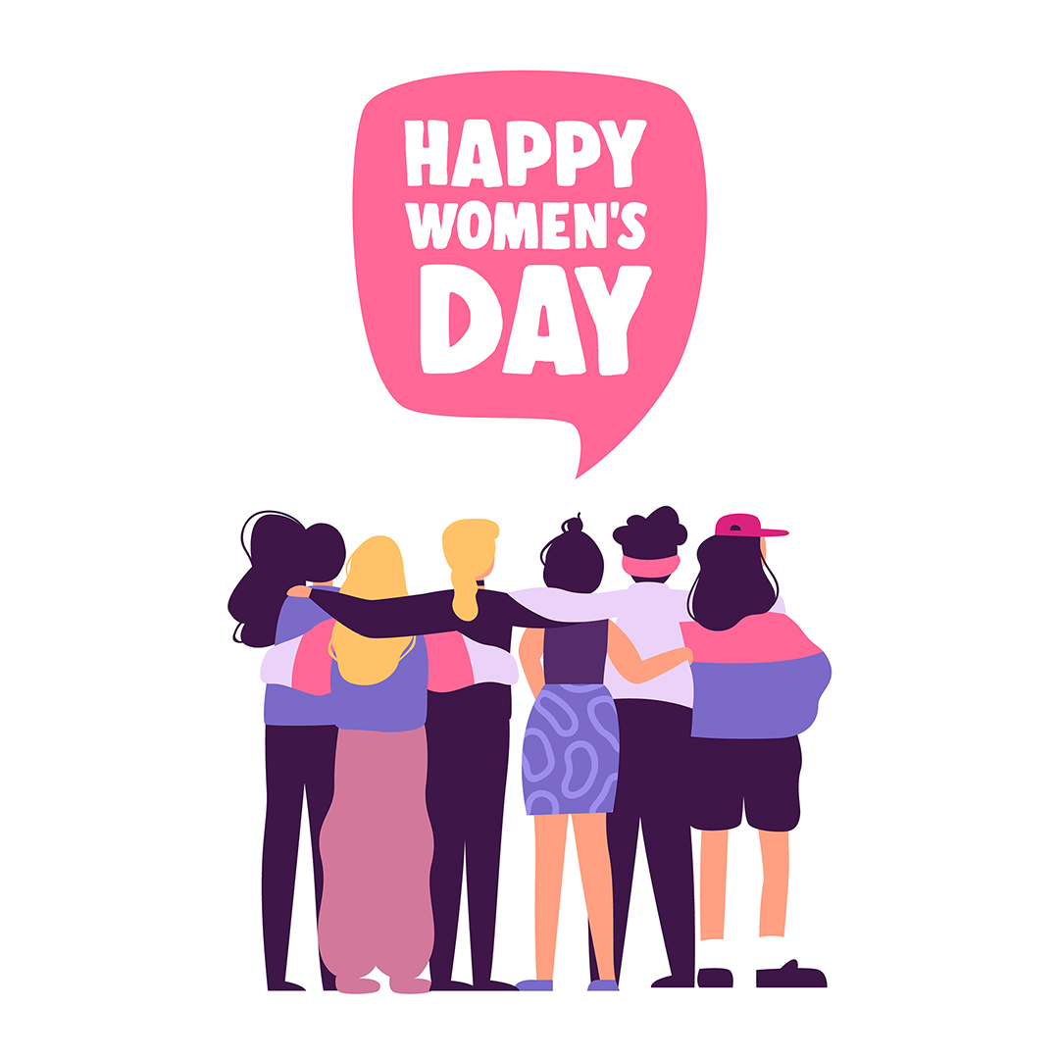

Important People Worksheet – World Book Kids

Learn more about your favourite Australian female authors using

Important People on World Book Kids.

• Click on Important People button on the World Book Kids homepage.
• If you know the name of the female author you would like to search for enter their name in this box and click ‘Go!’:
• Click on ‘Authors and Journalists’

• To search for a list of Australian authors use these buttons:
Use this button if you want to search for male or for female authors.  Choose on ‘female’ and click. | This button indicates your search has been narrowed to ‘Authors and journalists’. | Use this button to find Australian authors. Scroll down to ‘Australia’ and click. | Use this button to narrow your search to an author from a specific time-period.  Leave blank if you want to!

• After clicking the buttons a list of Australian female authors will appear. Scroll through the list to find an author you wish to learn more about and answer the questions below.

Find It!

Find the answers to the questions below using the article of the author you have found using the Important People tool:
- Who is the author you have chosen? _______________________________________________
- What type of writing does/did the author do? e.g. books/novels, poetry. _____________________________________________________________________________
- What are some of the things the author has written? ____________________________________
_____________________________________________________________________________
- Have you read any of the things the author has written? If so, what have you read? ___________ _____________________________________________________________________________
- What does the author write about? _________________________________________________
_____________________________________________________________________________
- Where was the author born? ______________________________________________________

