Click on Kids

www.worldbookonline.com

COMPARE PLACES WORKSHEET – WORLD BOOK KIDS
Compare Australia with Indonesia
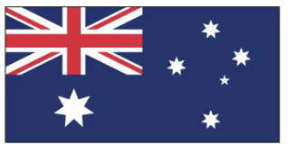

COMPARE PLACES:
This is where you can compare continents, countries, states, or compare everything with the click of a button.
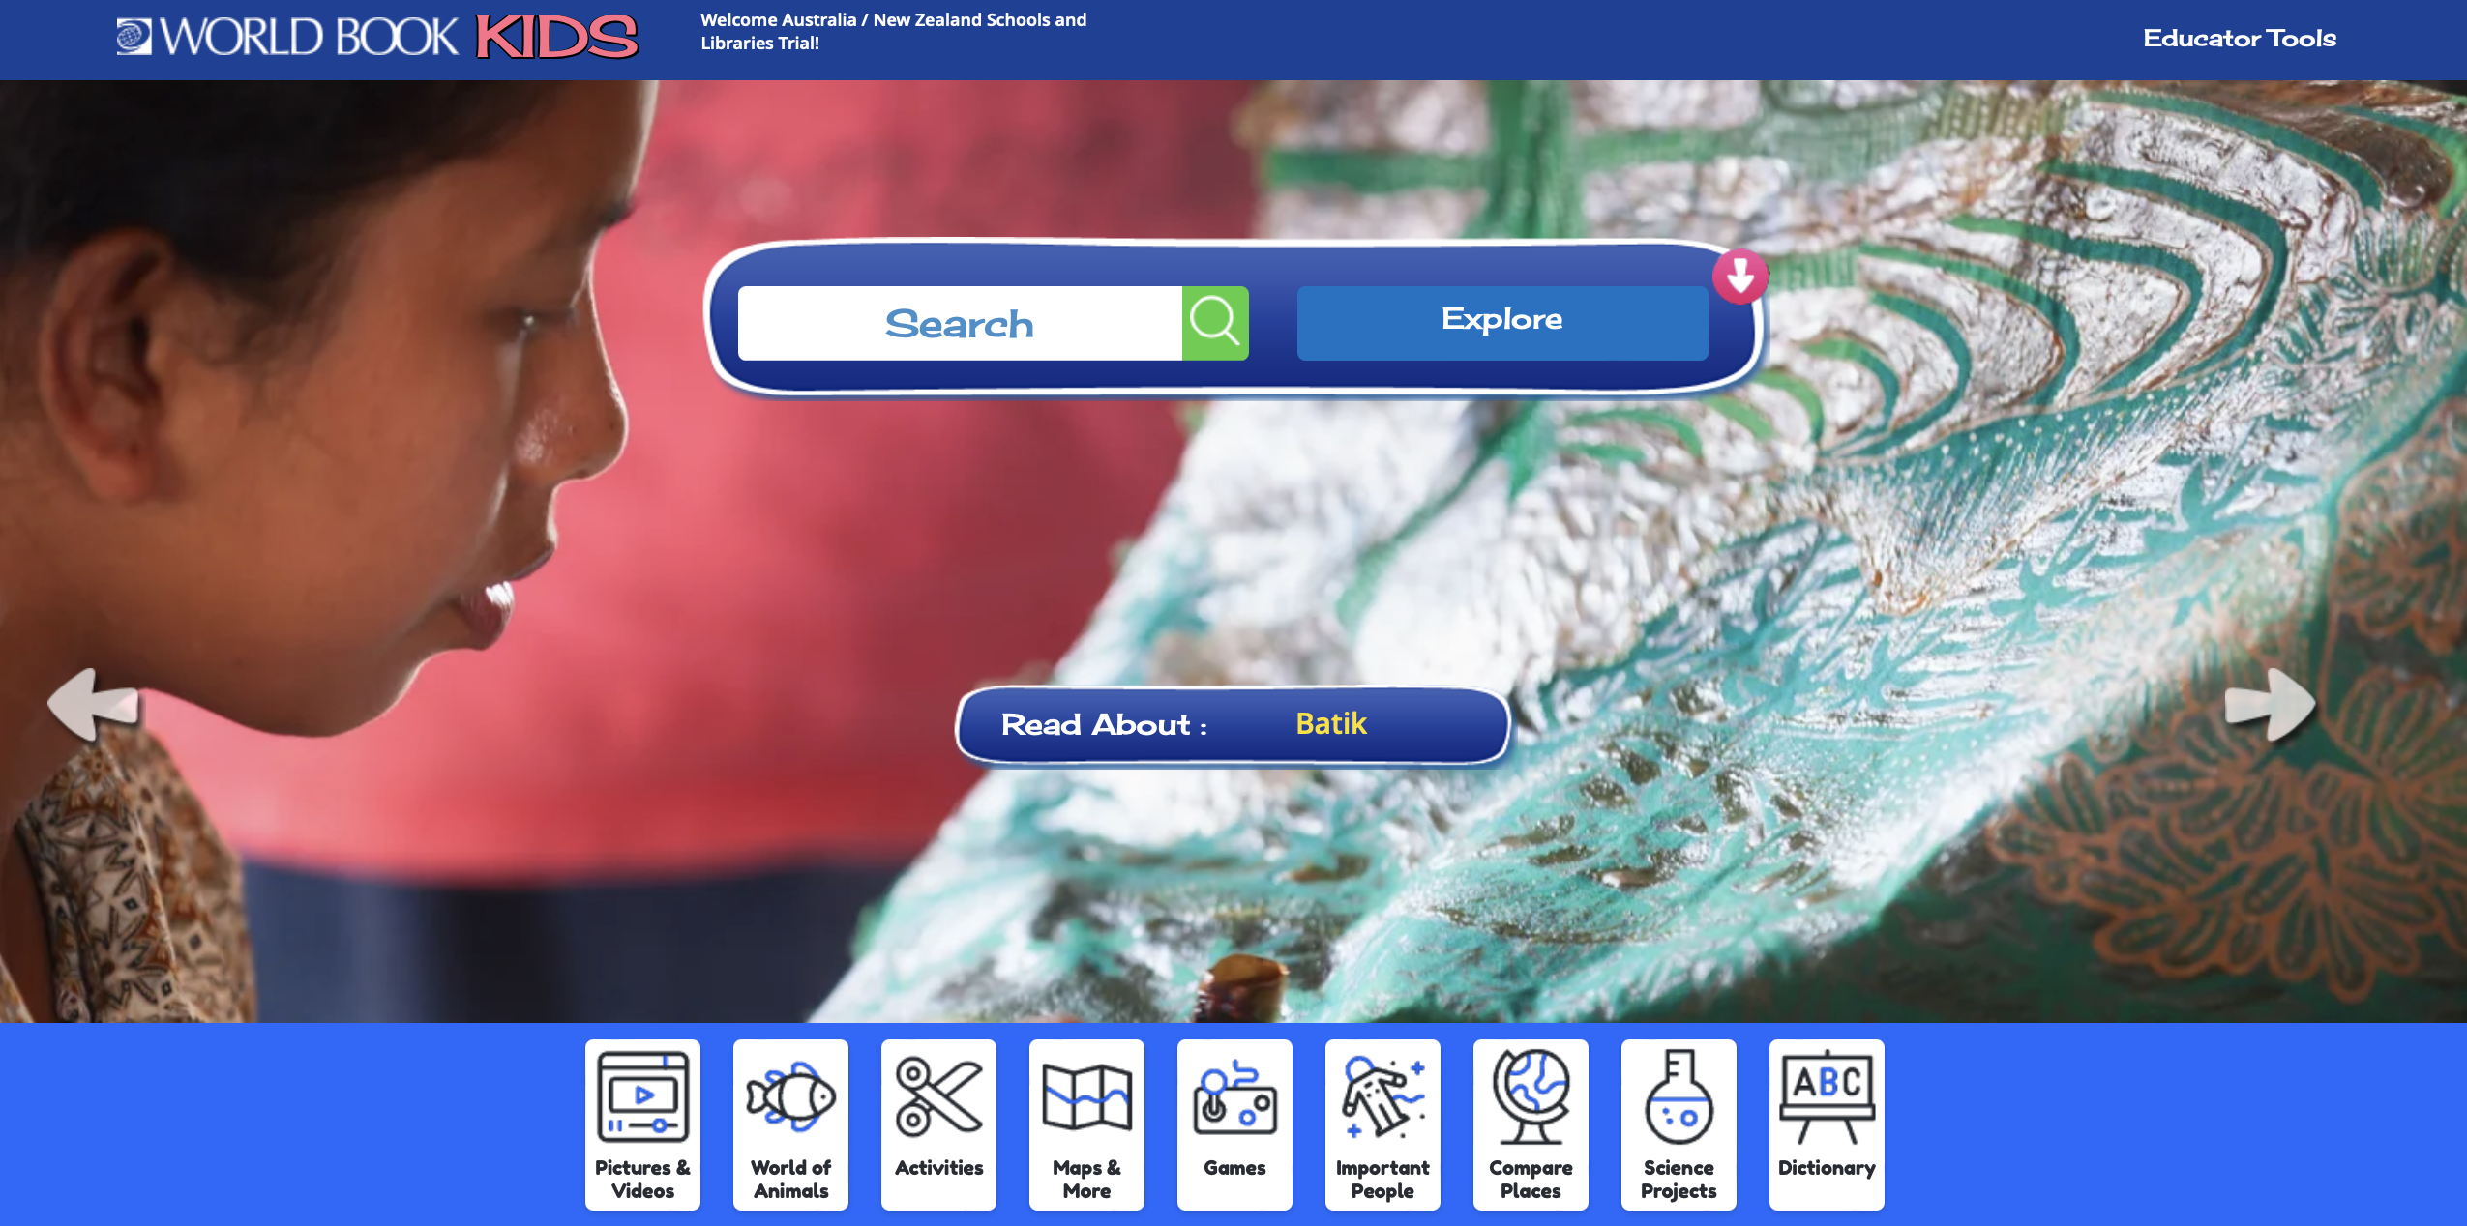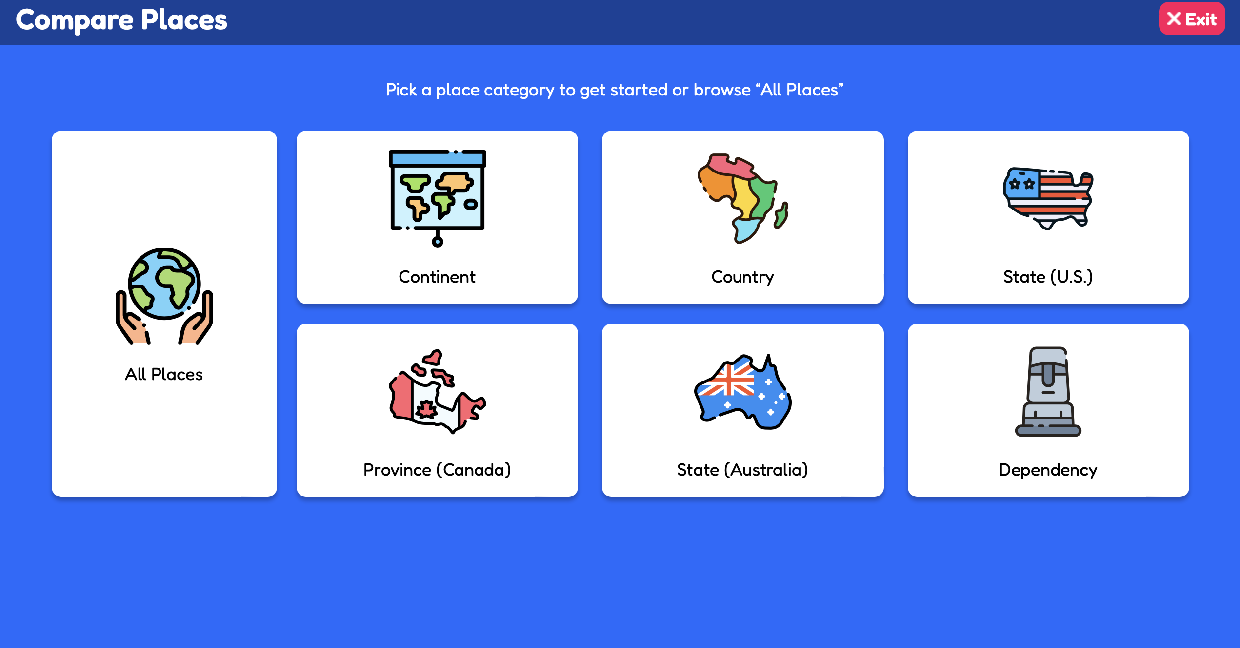
Let’s compare Australia with Indonesia –
Click on Compare Places button. 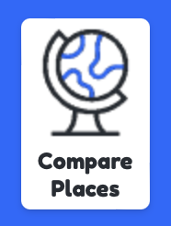
Click on Country button 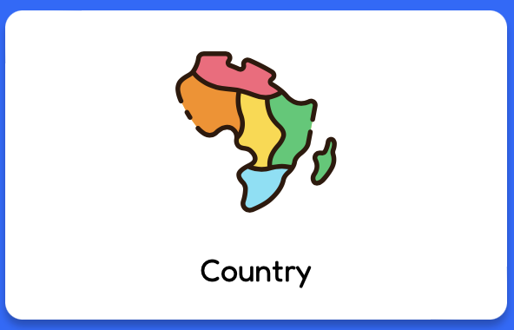 to compare Australia with Indonesia.

1. To choose Australia, click on the Australian flag  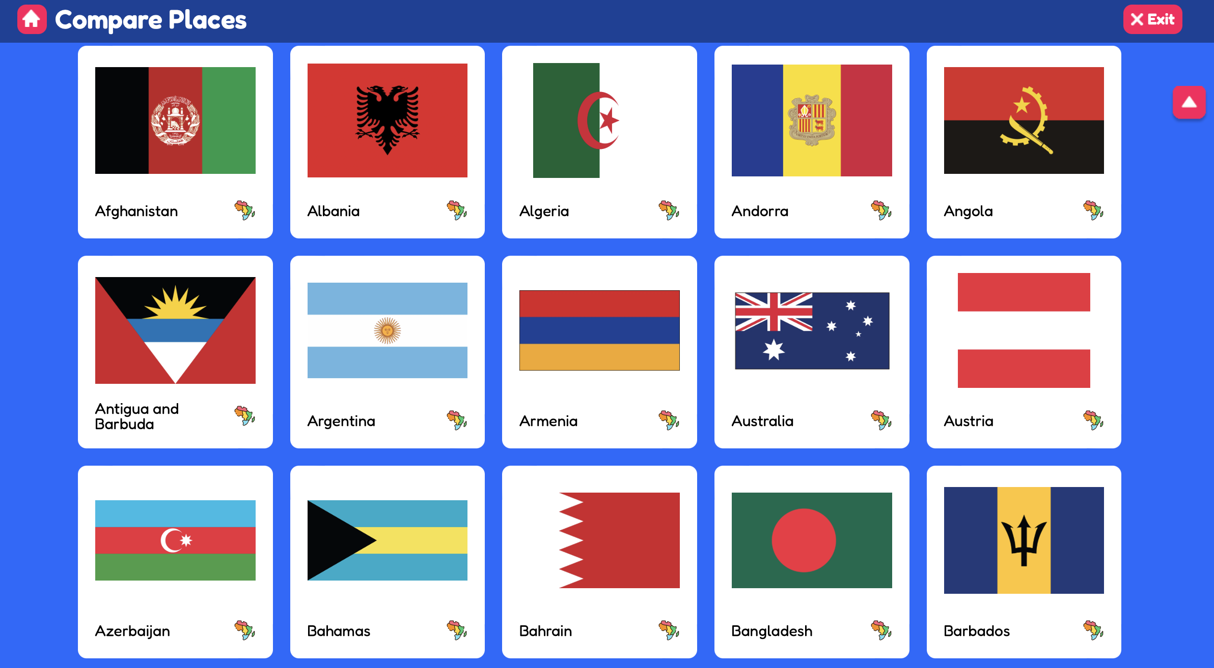 |  | 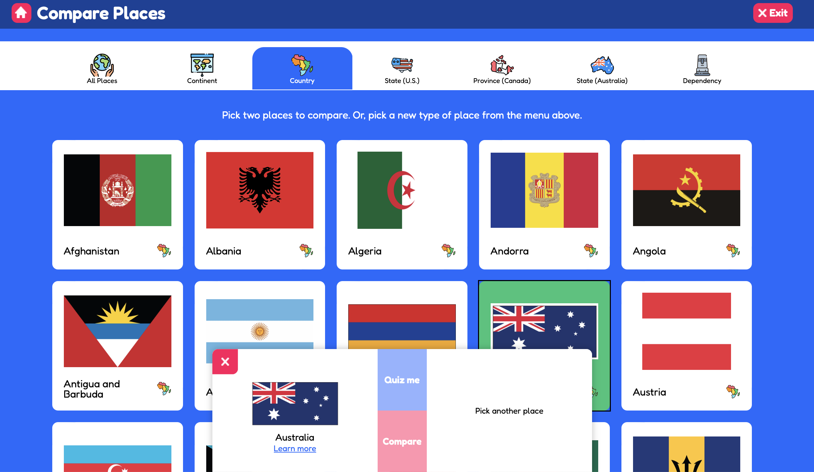
2. Search for Indonesia.  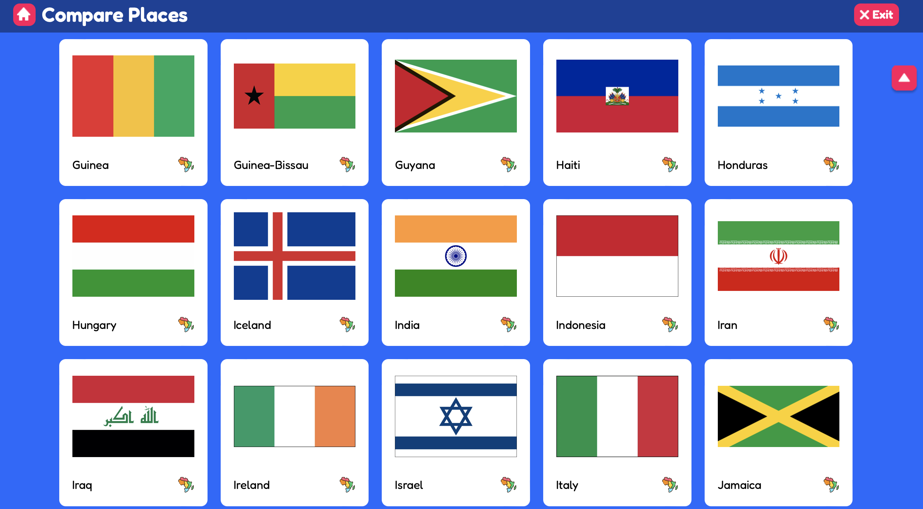 |  | 3. To choose Indonesia, click on the  Indonesian flag.  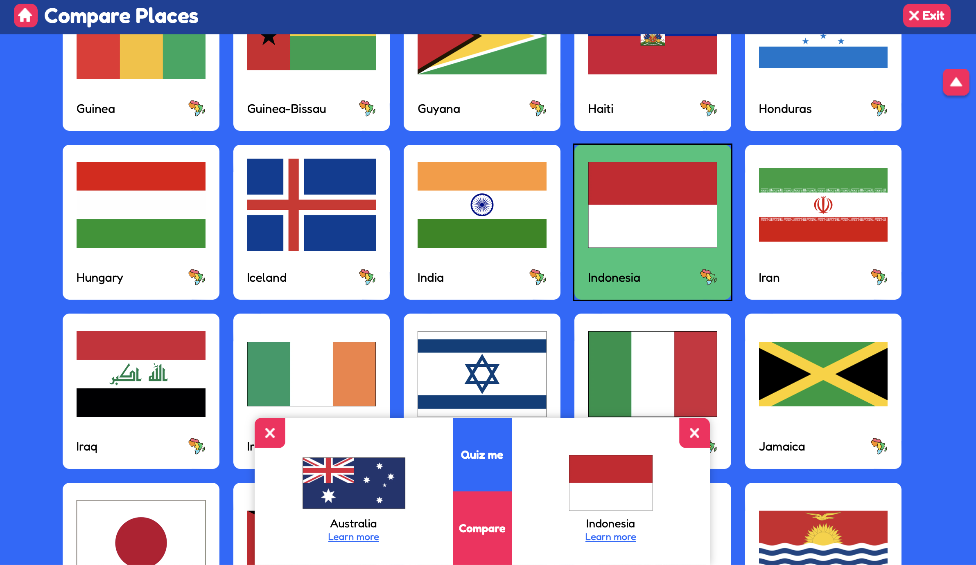
5. Click Quiz me and choose which answer you think is correct.  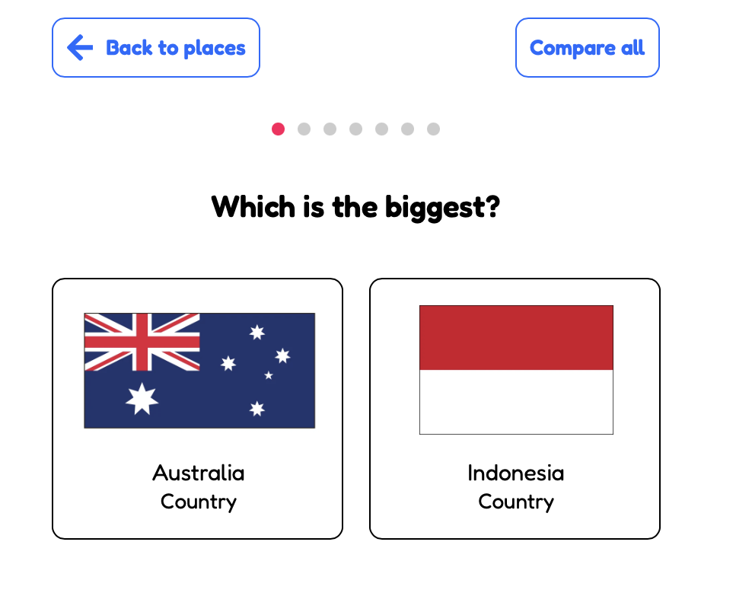 |  | 6. Click Compare All to compare both countries and find the answers to the questions below.  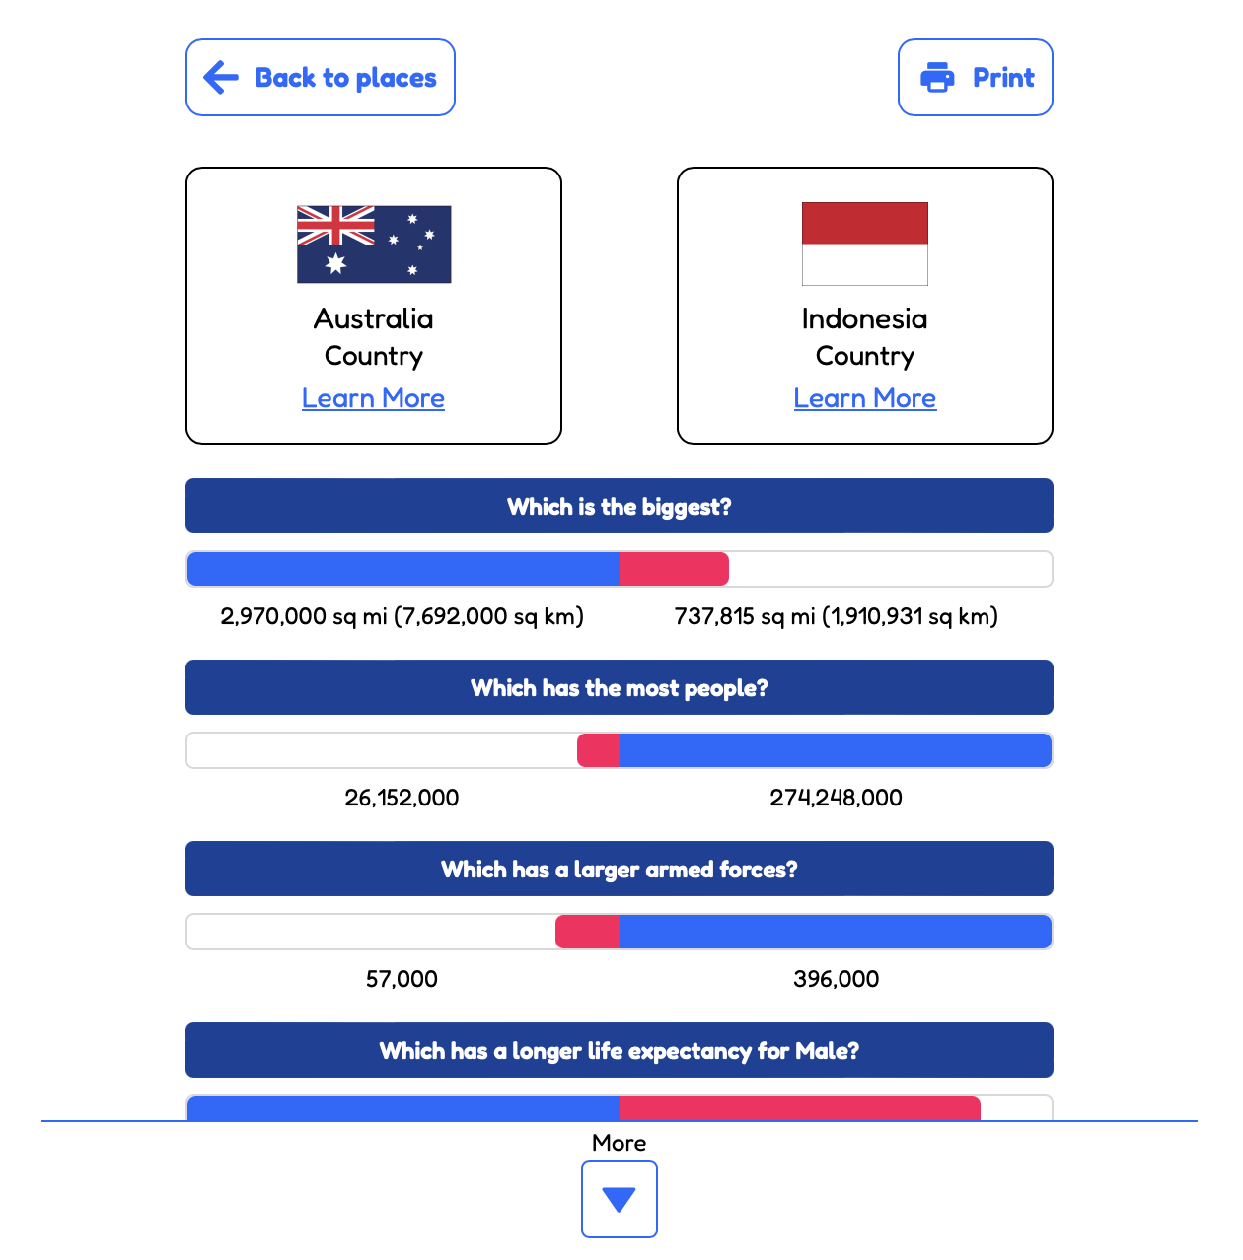
MORE QUESTIONS:
Which country has the largest population? ____________________________________________________________________________________
Indonesia is found on which continent? ____________________________________________________________________________________
The capital of Australia is ____________________________________________________________________________________
The capital of the Indonesia is ____________________________________________________________________________________
The highest mountain in Australia is ___________________________________________________________________________________
The highest mountain in Indonesia is ___________________________________________________________________________________
Name one famous place in Australia ___________________________________________________________________________________
Name one famous place Indonesia
___________________________________________________________________________________

6. Click Learn More 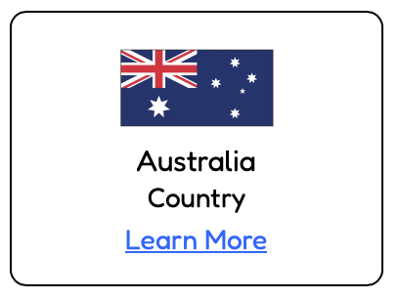 to find facts about Australia.  Listen to Australia’s national anthem. | 7. Click Learn More 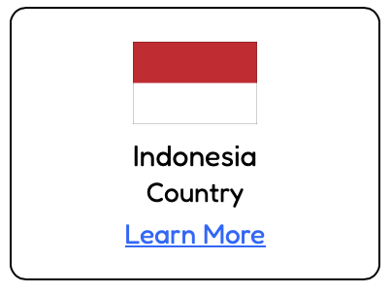 to find facts about Indonesia.  Listen to Indonesia’s national anthem.

- Colour the flag of Australia
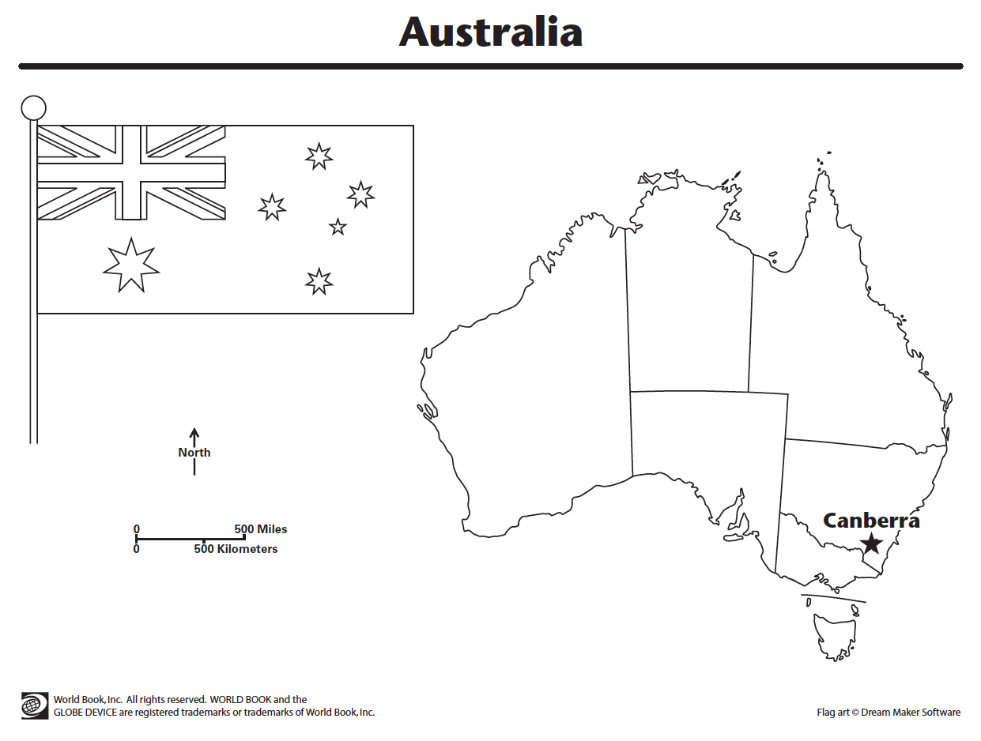
- Colour the flag of Indonesia.
