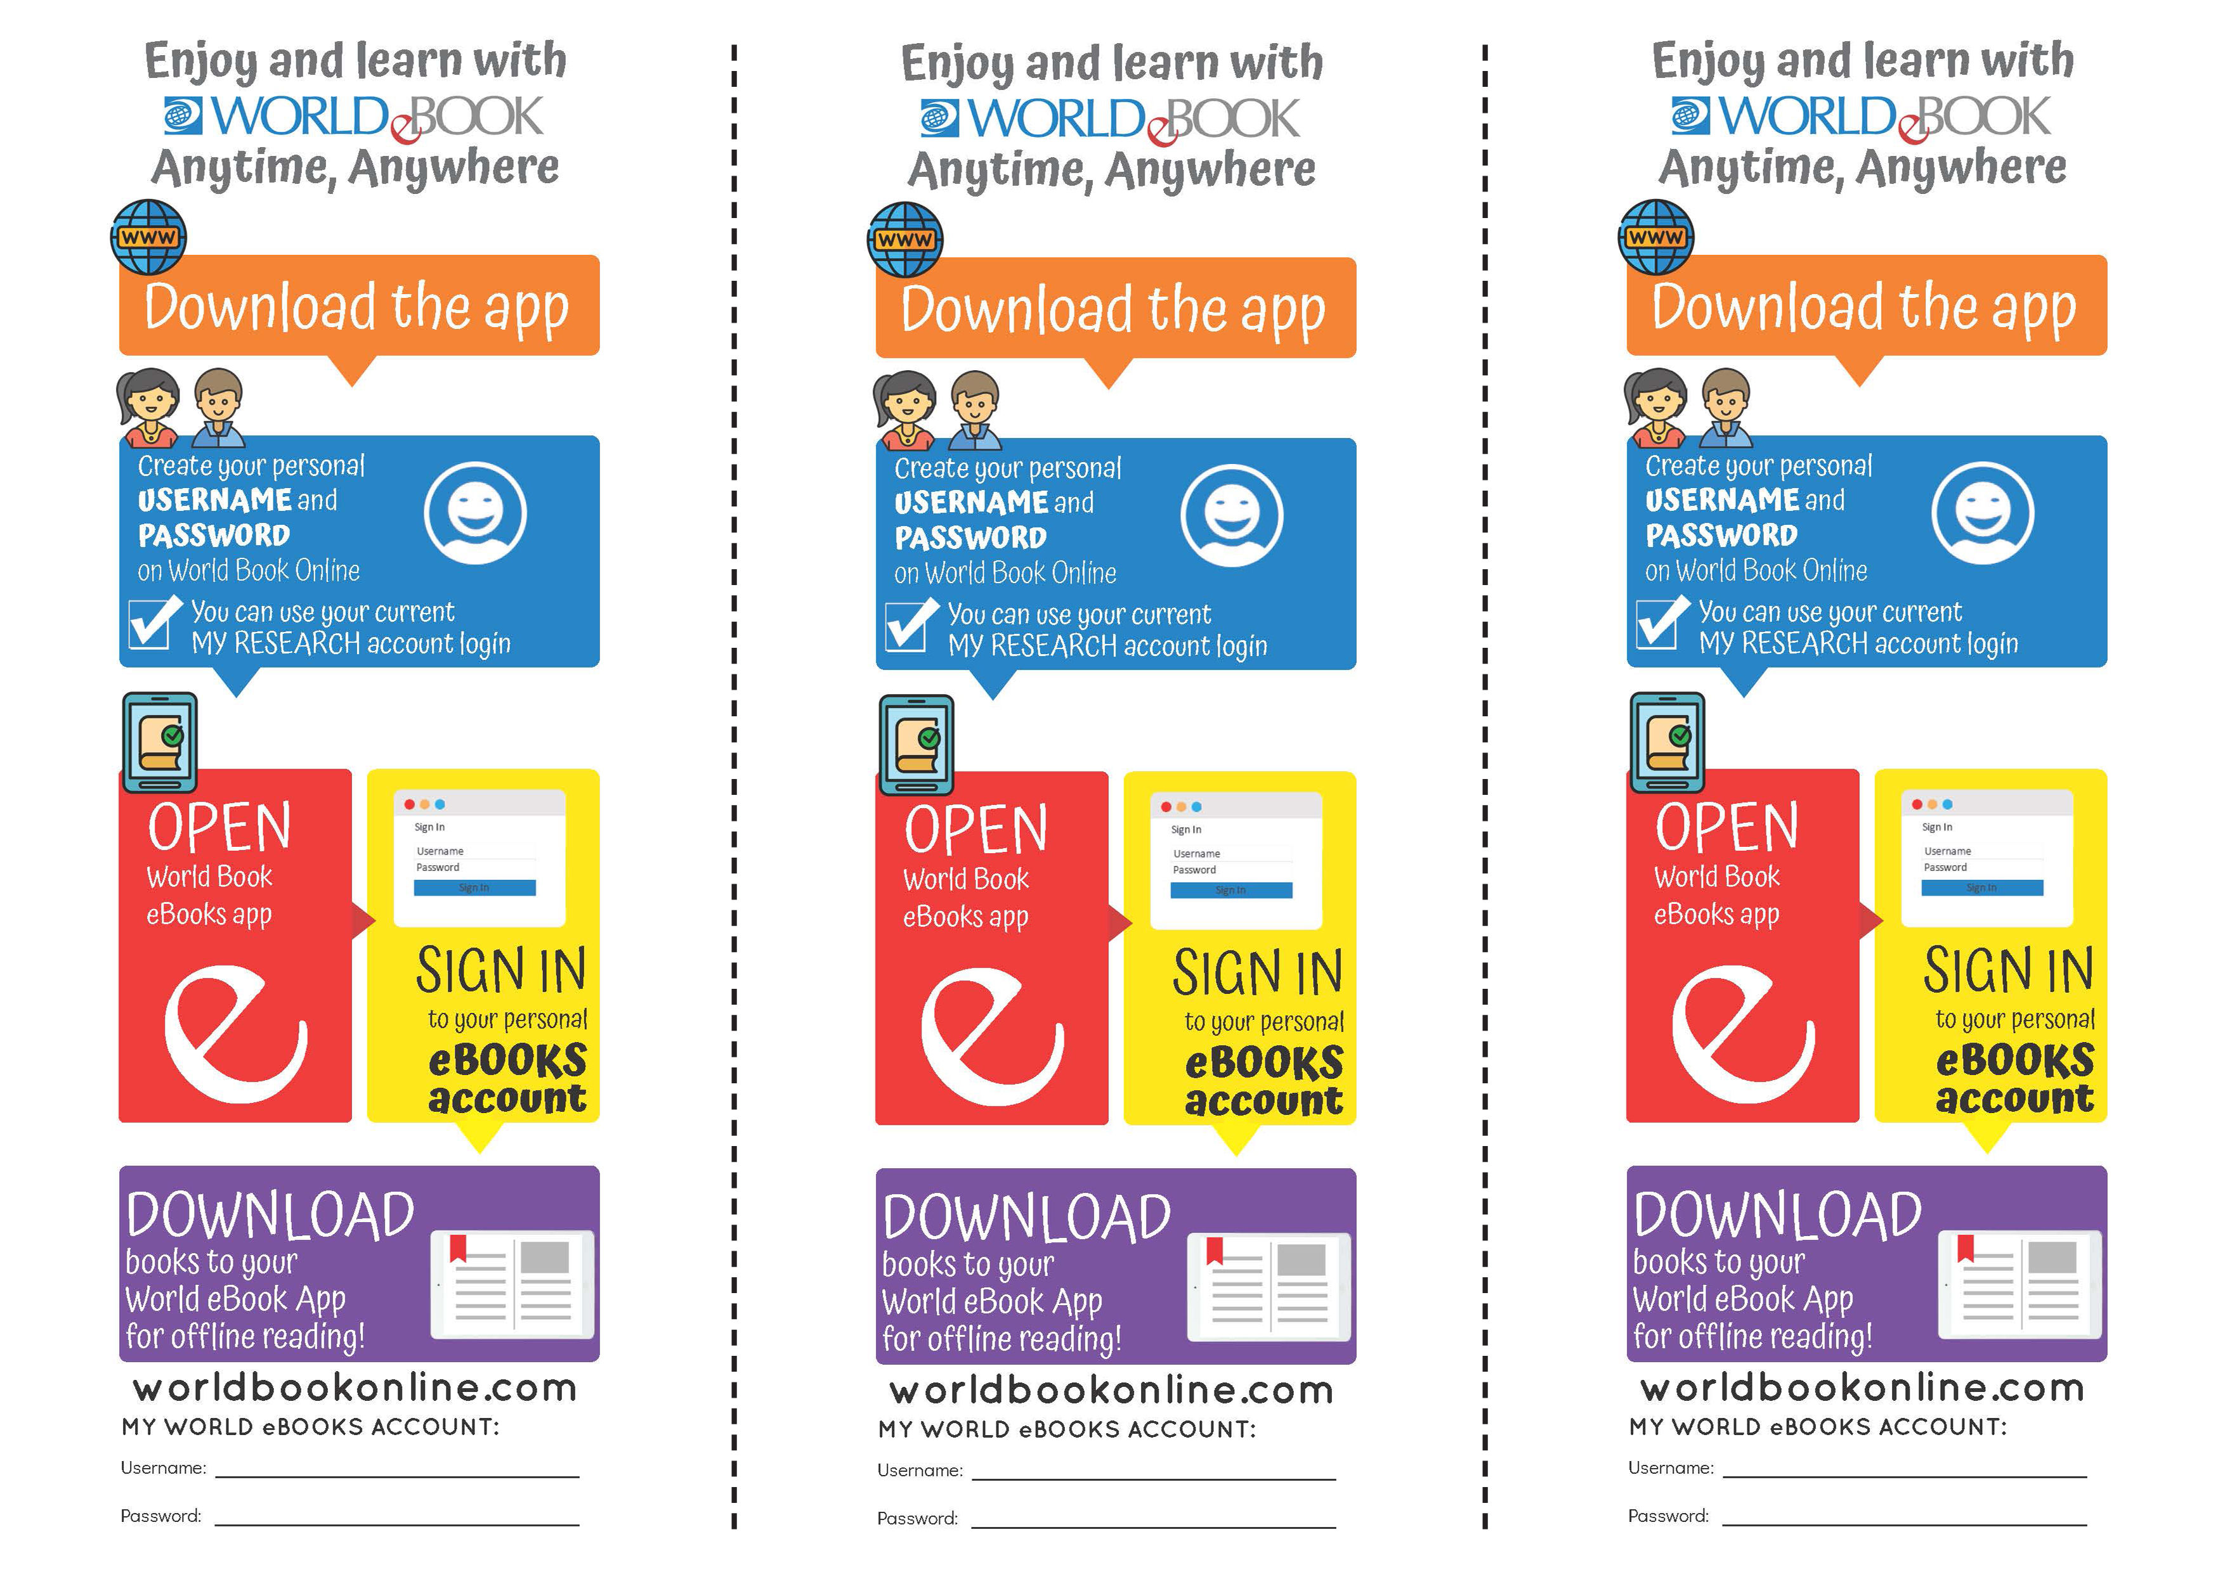

{insert username}

{insert password}

{insert username}

{insert password}

{insert username}

{insert password}