Antarctica STUDENT Worksheet
Did you know that Antarctica is colder than the icy region of the Arctic Ocean centred on the North Pole? Learn more about Antarctica on World Book Online.
Go to www.worldbookonline.com Click on Student
Type Antarctica in the search box in World Book Student.
Click on the Antarctica article and answer the question below.
1. What is unique about Antarctica?
___________________________________________________________________________
Scroll down to section Geography/Land and answer the question below.
2. What is the highest point in Antarctica?
___________________________________________________________________________
Scroll down to section Geography/Ice and answer the question below.
3. What is the process called when the ice reaches the coast, breaks off to form icebergs that are then carried out to sea?
___________________________________________________________________________
Scroll down to section Ocean and answer the question below.
4. Each winter, the surface of the Southern Ocean freezes into a sheet of salty ice. What is this sheet of ice called?
___________________________________________________________________________
Scroll down to section Climate and answer the question below.
5. What was the world’s lowest temperature recorded by scientists on July 21, 1983?
___________________________________________________________________________
Scroll down to section Living Things and answer the question below.
6. What is the most common penguin found in Antarctica?
___________________________________________________________________________

Scroll down to section Exploration/The “Heroic Era” and answer the questions below.
7. Who were the two explorers racing to be the first to reach the South Pole?
___________________________________________________________________________
8. Who reached the South Pole first?
___________________________________________________________________________
Click on the MEDIA tab and click on Antarctica territorial claims map.

9. On the map of Antarctica below mark in the territorial claims.
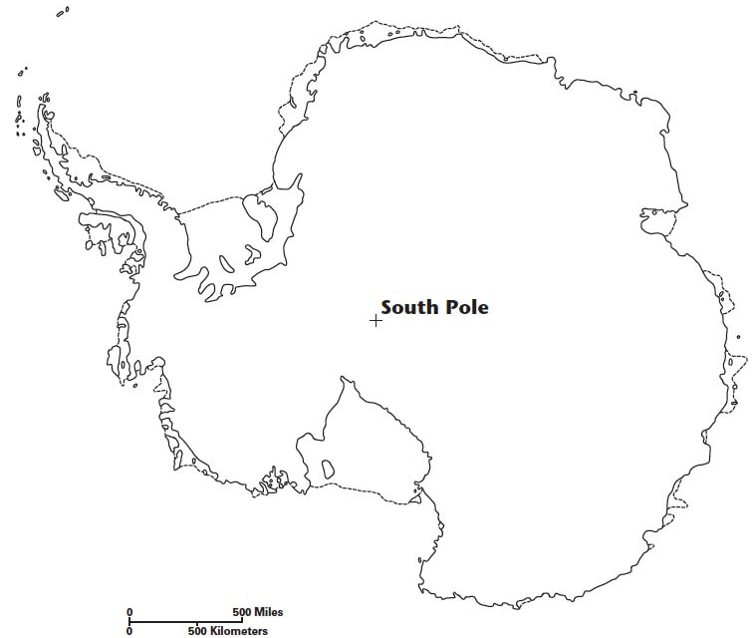
Click on the RELATED INFORMATION tab and under Biographies click on Mawson, Sir Douglas article. Scroll down to section Second Antarctic expedition and read the information box in the exploration map to find the answer the question below.
10. What tragedy occurred in December 1912 during the 1911 – 14 Australasian Antarctic Expedition?
______________________________________________________________________________
______________________________________________________________________________
______________________________________________________________________________
______________________________________________________________________________
ANSWER KEY:
1. Antarctica is the coldest, highest, brightest, driest, and windiest continent on Earth.
2. Vinson Massif
3. Calving
4. Sea ice
5. Scientists recorded the world's lowest temperature, –89.2 °C, at Antarctica’s Vostok Station, on July 21, 1983.
6. Adélie penguin
7. Scott and Amundsen
8. Amundsen's group arrived at the South Pole on Dec. 14, 1911. Scott's group reached the pole on Jan. 17, 1912, finding Amundsen's flag.
9. Antarctica territorial claims
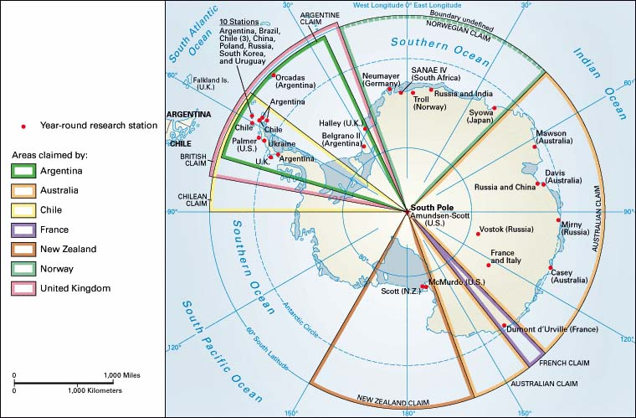
10. Ninnis, who carried most of the group’s supplies, fell to his death, so the two survivors, Mawson and Mertz, were left without provisions. Desperate for food, they killed and ate their sled dogs. However, the constant diet of dog liver poisoned the two men with only Mawson surviving.

