Bushranger Ned Kelly – Timelines
Ned Kelly is the most famous of Australia’s bushrangers. Bushrangers were bandits who operated in rural Australia for 110 years during colonial times. Learn more about Ned Kelly by answering the questions below and construct a Timeline of his life using the answers.
Go to www.worldbookonline.com and log in using your school’s log in details:
Log-in ID:

Password:

Click on Student
Type in Ned Kelly in Search box
Click the article titled Ned Kelly
- Where and when was Ned Kelly born?
_____________________________________________________________________
- Why did Ned Kelly’s father, John Kelly leave Ireland to come to Australia and what year did he arrive?
__________________________________________________________________________________________________________________________________________
- In what year did the Kelly family move to Avenel in central Victoria?
_____________________________________________________________________
- What year did Ned Kelly’s father, John die?
_____________________________________________________________________
- In 1866, the family moved to where?
_____________________________________________________________________
- In what year was Ned Kelly convicted of assault?
_____________________________________________________________________
- In 1871, shortly after his release from prison, Ned Kelly was convicted of another crime. What crime was he convicted of committing?
_____________________________________________________________________
_____________________________________________________________________
- When was he released from prison for committing this crime?
_____________________________________________________________________
- In what month and year is it claimed that police officer, Andrew Fitzpatrick, was shot at the Kelly home?
_____________________________________________________________________
- In what year were three police officers killed while trying to capture or kill Ned and his brother, who had escaped to the bush after the incident with Andrew Fitzpatrick?
_____________________________________________________________________
- Name the members of the Kelly Gang?
_____________________________________________________________________
- When did the Kelly Gang rob a bank in Euroa, Victoria?
_____________________________________________________________________
- Two months later, the Kelly Gang raided the town of Jerilderie. What month and year did this happen?
_____________________________________________________________________
- In what month and year did the Kelly Gang take over the railway village of Glenrowan, which resulted in a siege with over 50 police officers?
_____________________________________________________________________
- Ned Kelly was captured following the siege and stood trial for murder on what date?
_____________________________________________________________________
- After being found guilty, Ned Kelly was hanged in Melbourne jail on what date?
____________________________________________________________________
- Use your answers to make a Timeline of Ned Kelly’s life.
Scroll to bottom of page and select TIMELINES.
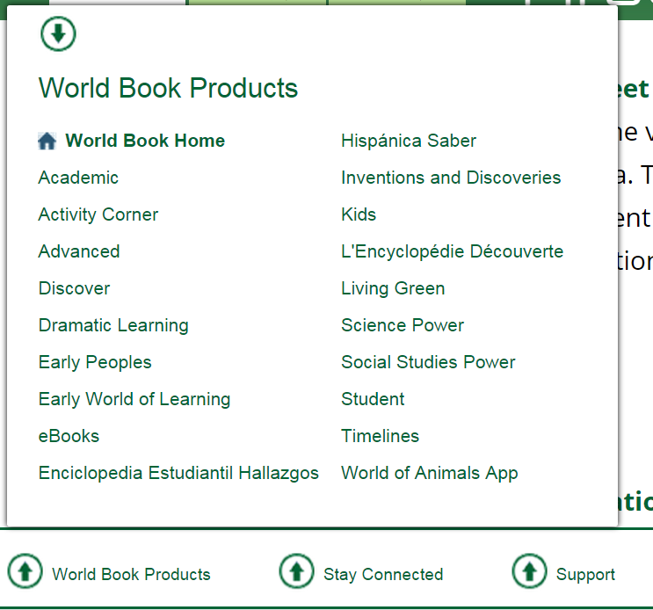
- Log in to your My Research Account using your personalised log in details – this is how you save your Timeline
- Click “Create a Timeline” to create a timeline.

- Click “Create Event” to enter in an event
- Provide the date and summary of the event that happened during that time. You can add images and additional facts about the event too.
To add images to do with the Ned Kelly to your event:
Type “Ned Kelly” in Search Box. Select image, click “Add”, and then click “Save”. You can add your own images too by clicking “Upload” and saving your own images to the Timeline.
- Don’t forget to save your Timeline!

