Rainforests – Activities for World Book Kids
KIDS WORLD OF ANIMALS - RAINFOREST ANIMALS
► Go to www.worldbookonline.com
► Click on Kids
► Go to World of Animals
Complete the Rainforest Animals table below by searching each animal using the Search box.
► Click on the Search button and type each search word/s in the Search box.
► Click on for each animal, located in the left-hand box.
► Scroll down the page to complete the table. Click the to close.

TABLE: RAINFOREST ANIMALS
SEARCH | Where found? | Sample of food it eats | Conservation status
Flying Dragon
(Flying Dragon)

Gorilla
(Lowland Gorilla)

Toucan
(Toco Toucan)

Parrot
(Scarlet Macaw)

Sloth
(Two-toed Sloth)

Tapir
(Malayan Tapir)

ANSWERS:
KIDS WORLD OF ANIMALS
SEARCH WORDS | Where found? | Sample of food it eats | Conservation status
Flying dragon | Southeast Asia | Ants and termites | Least concern
Gorilla  (Lowland Gorilla) | Central Africa | Leaves, bark and fruits | Endangered
Toucan  (Toco Toucan) | Central and South America | Mostly fruits, but also insects and small animals | Least concern
Parrot  (Scarlet Macaw) | Central and South America | Fruits and nuts | Least concern
Sloth  (Two-toed Sloth) | South America | Leaves, fruit, buds, and young twigs | Least concern
Tapir  (Malayan Tapir) | Southeast Asia | Grasses, leaves, water plants, and twigs | Endangered

Rainforests - World Book Kids Activities
KIDS - RAINFOREST MAP
► Go to www.worldbookonline.com
► Click on Kids
► Click on Explore
► Click on Places
► Click on Natural Features
► Click on Forests
► Click on Rain forest > click on the tab.
► Click on the Rain Forest map under Maps.
Colour the area where rainforests are located on the world map:
RAINFOREST AREA
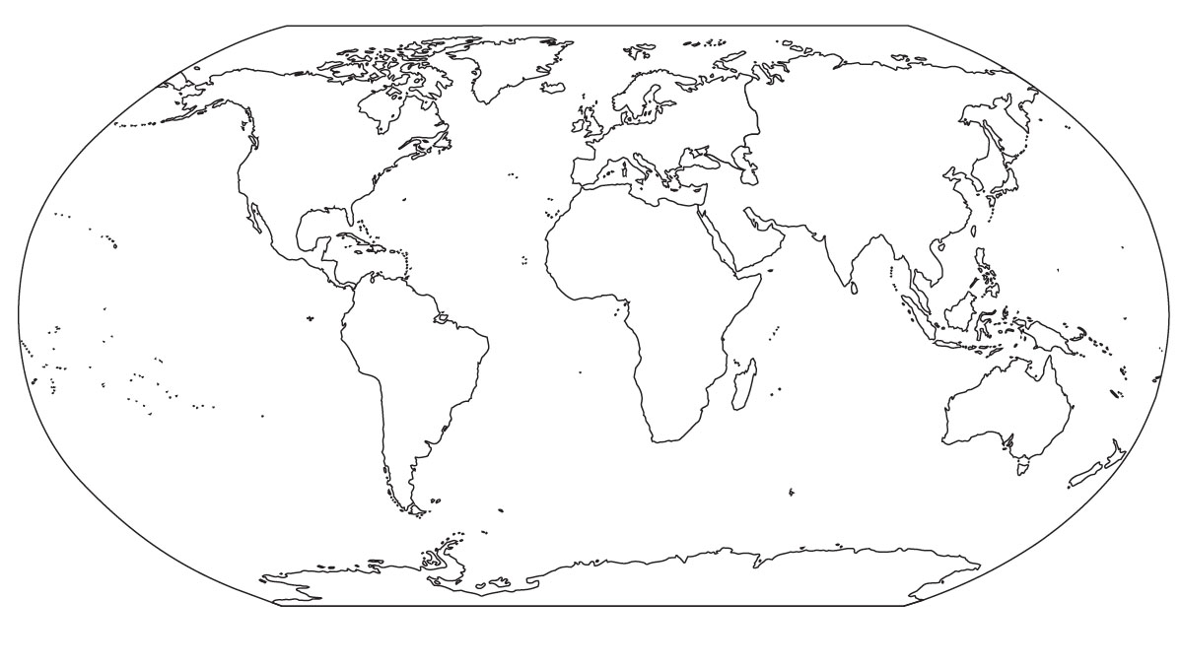
ANSWER:
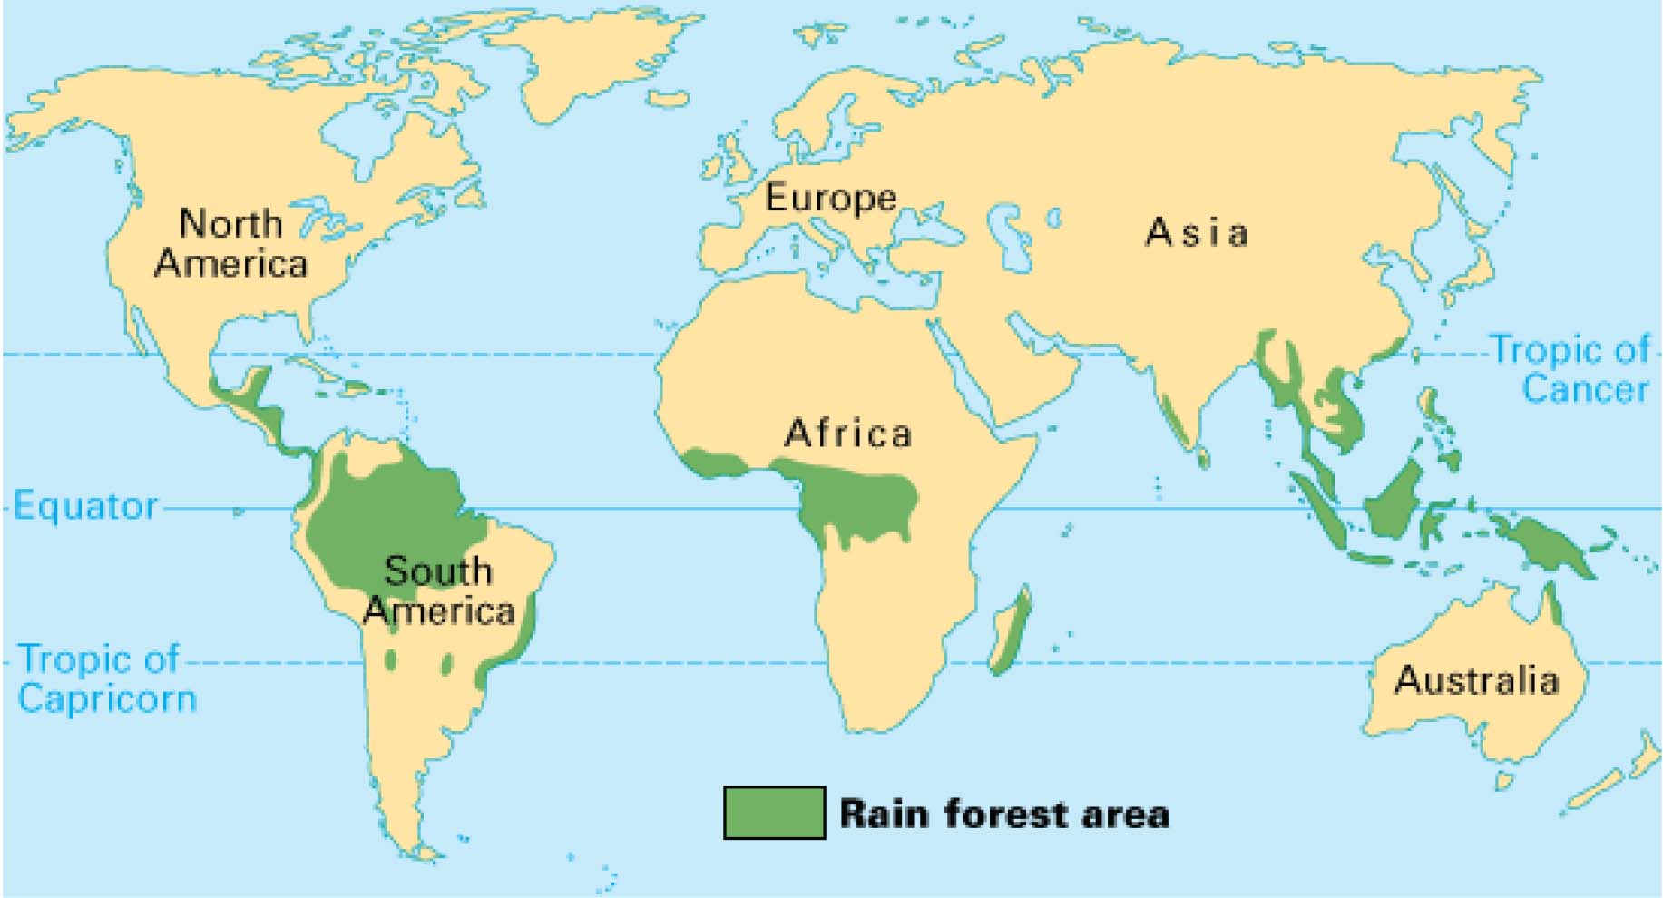

Rainforests - World Book Quiz

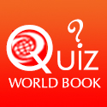 WORLD BOOK RAINFOREST QUIZ

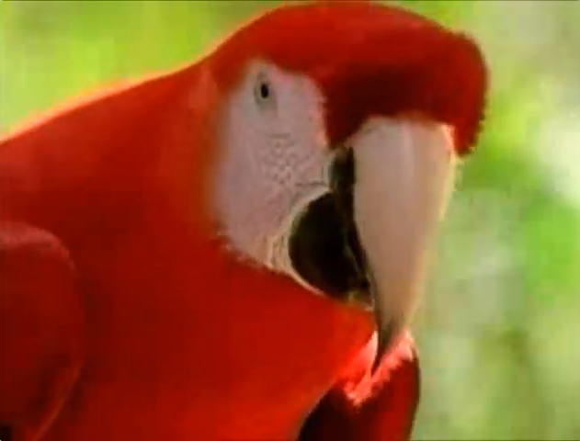
► Click here to start quiz
OR
Scan this code with your mobile device using your camera
and open WEBSITE QR CODE in your browser.

