**  
Timelines – Charlemagne**

**Go to** [**www.worldbookonline.com**](http://www.worldbookonline.com) **and log in using your school’s log in details:**

|  |  |
| --- | --- |
| **Log-in ID:** |  |
| **Password:** |  |

**Click on Advanced **

**Type in *Charlemagne* in Search box**

**Click the article titled *Charlemagne***

**Read the article and answer the questions below.**

1. **In what year is Charlemagne said to be born?**

_________________________________________________________________________

1. **Charlemagne was the son of the King of the Franks. What is the name of his father and what year did his father become King?**

_________________________________________________________________________

1. **What year did Charlemagne’s father die?**

_________________________________________________________________________

1. **Charlemagne shared rule of the Frankish Kingdom with his brother. What was his brother’s name and in what year did his brother die?**

_________________________________________________________________________

1. **What year did Charlemagne become the sole ruler of the Frankish kingdom?**

_________________________________________________________________________

1. **Upon his succession to the throne, Charlemagne immediately began expanding his kingdom. Over the course of his reign he conquered territories throughout Europe. His longest campaign was against the Saxons. Approximately, how many years were they at war and what years did they run through?**

_________________________________________________________________________

1. **Charlemagne’s campaigns extended to Spain. In what year were his rear guard ambushed and wiped out by the Basques people?**

_________________________________________________________________________

1. **Following decades of campaigns, Charlemagne’s realm extended from central Italy north to Denmark and from eastern Germany west to the Atlantic Ocean. In what year was this achieved?**

_________________________________________________________________________

1. **Charlemagne followed a policy of friendship and cooperation with the Christian church. Pope Leo III crowned Charlemagne emperor of the Romans on what date?**

_________________________________________________________________________

1. **What date did Charlemagne die?**

_________________________________________________________________________

1. **Following his death, Charlemagne’s kingdom gradually fell apart. What happened in 843?**

_________________________________________________________________________

1. **Over what period did Charlemagne build his kingdom?**

_________________________________________________________________________

1. **Place events into a Timeline.**

Scroll to bottom of page and select TIMELINES.

* Log in to your My Research Account using your personalised log in details – this is how you save your Timeline



* Click “Create a Timeline” to create a timeline.



* Click “Create an Event” to enter in an event



* Provide the date and summary of the event that happened during that time. You can add images and additional facts about the event too.

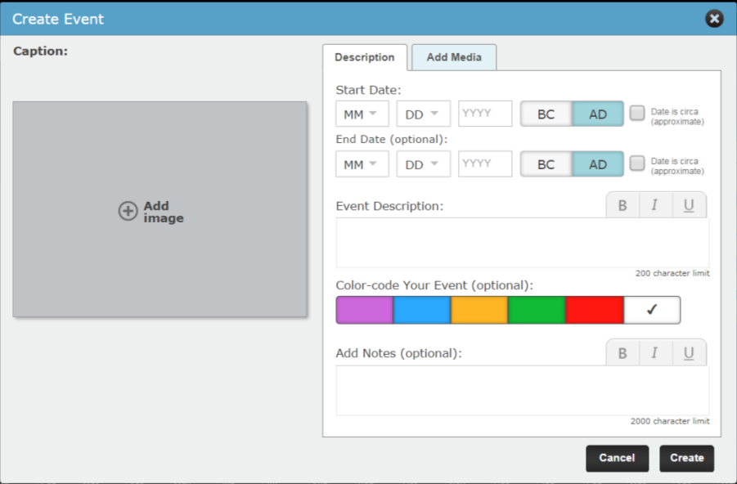

To add images to do with Charlemagne to your event:

Type “Charlemagne” in Search Box. Select image, click “Add”, and then click “Save”. You can add your own images too by clicking “Upload” and saving your own images to the Timeline.

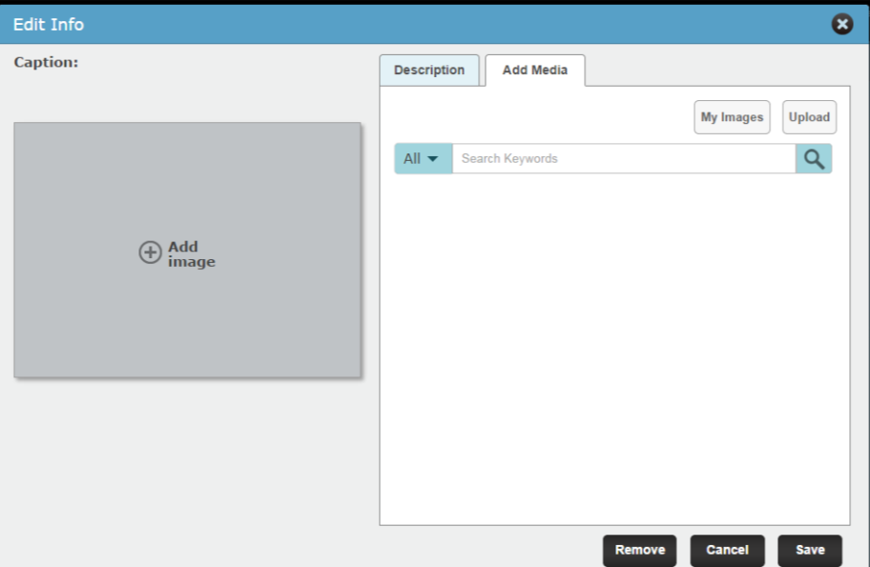

* Don’t forget to save your Timeline!



**Charlemagne Worksheet**

Answers:

1. 742
2. Pepin the Short, he became King in 751.
3. 768
4. Carloman and he died in 771.
5. 771
6. 30 years. (c.771-801)
7. 778
8. 800
9. 25 December, 800
10. 2 January 814
11. In 843 the kingdom was divided into three parts amongst Charlemagne’s grandsons.
12. 768-814
13. Timeline



