Dear Parents,

Great news! Our school has a subscription to World Book Online! This means you have FREE access from home or on the go with any internet-connected device.

What is World Book Online?

A safe, trusted, 21st-century learning environment for students.

- Homework help  - Read stories, articles, and current events  - Complete activities and Webquests  - Play educational games  - Look up places with interactive maps | - Easily cite sources with the citation builder  - Learn how to do research  - Explore pictures and videos  - Find reliable information for assignments and projects | 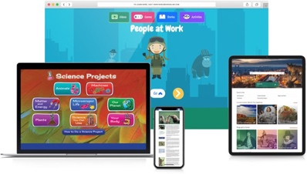

iPad | Computer
- Visit www.worldbookonline.com.  - Log in using the username and password provided by your school.  - Check the box labeled Remember my ID and password for faster login next time.  - Select the arrow up icon located in the top right corner of the browser screen.  - In the bottom row of the pop-up screen, select the Add to Home Screen icon.  - We recommend shortening the name to “World Book Online.”  - Select Add. | - Visit www.worldbookonline.com.  - Log in using the username and password provided by your school.  - Check the box labeled Remember my ID and password for faster login next time.  - Bookmark the page and add it to favourites.

Encourage
Learning Anytime,
Anywhere!

Username:
Password:

Research Learn Explore
Encourage Learning Anytime, Anywhere!

Username: Password:

