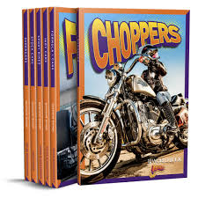
Bolt Gearhead Garage
Choose the book from this series that you would like to read. Write your name and class on a post-it note and place it inside the front cover. Don’t choose a book that someone else in your class has already chosen. It doesn’t matter if someone in another class is also using this book.
Tick next to the title you chose from the list below

Tick | Name of Book | Tick | Name of Book
 | Lowriders |  | Top Fuel Dragsters
 | Stock Cars |  | Muscle Cars
 | Choppers |  | Funny Cars
 | Formula 1 Cars |  | Indy Cars
 | Sport Bikes |  | Hydroplanes
 | Dirt Bikes |  | Supercars
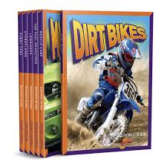
Answer these questions about your book
Look at the Cover
- What is the salient image on the front cover – what do you first look at – the title, the picture, the publisher (World Book) or the series (Bolt). Underline your answer

- Why did you choose that – was it because of its size; position on the cover; colours used. Underline your answer

- What colour stands out the most on the cover of your book?

- Look at the title – does the use of the spotty background behind the title make the title stand out more or less? Underline your answer.

- Look at the colours chosen for the title – what are they? What do those colours make you feel – excited, hot, cold, energetic (that lots of things might happen in this book), dull or bored. Underline your answer

Look at the spine of the book
- What is written on the spine?

Look at the back cover of the book
- Read the blurb. What do you think “Rev up your reading engines!” means?

- What are the 2 alliterative words (start with the same letter) in the first sentence in the blurb?

- Underneath the blurb there are the picture of 6 books in the Gearhead Garage series. What is similar about the titles on the cover of each book? Think about the style of writing/ shape of the title/ choice of colour/use of capital letters or lowercase letters/ position of the title on the page. Write down what is similar using your own words.

- Look at the images on each of the 6 books - what is similar about them? Think about size/ can you see all of the picture or only part of it/ are there people in each vehicle/ colours of the vehicles. Write down what is similar using your own words.

Turn to the title page of the book.
- Who is the author of your book?

- Is the style of the title the same or different to the cover? Underline your answer

- Look at the background carefully. What can you see?

- Look at the colour of the background. Where else can you see this colour on the cover?

Look the Table of Contents
- What is the salient image on this page?

- What is the background colour on this page? What images can you see in the background?

- How many chapters are in your book?

- Which chapter are you most interested in reading? Why?

- Which page do you need to turn to, to read this chapter that you are the most interested in?

Look at the Glossary (page 30)
- What is a glossary – what does it tell you?

- Choose one of the words from the Glossary that you didn’t know the meaning of – write it down, with its meaning.

Look at the Index (page 32)
- The index tells you on which page you will find information about something. Which entry (subject or topic) in the Index has the most pages?

Look at the book
- Write down an interesting fact you learned in this book.

