Animal Lives –
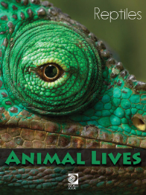
Reptiles Activity Sheet
Find under Animals: Amphibians, Reptiles, and Sea Creatures

1. What are the four groups of reptiles?
1)
2)
3)
4)
2. After reading all about snakes, write a brief description of a snake.

3. Alligators and crocodiles belong to which group of reptiles?
a. crocodilians
b. caimans
c. tuataras

4. Name at least two differences between tuataras and lizards.
1)
2)

5. True or False: Reptiles are warm-blooded.
6. True or False: Waterproof skin helps reptiles from drying out in the desert.
7. What is your favourite reptile?

