Great news! Our school has a subscription to World Book Online! This means you have FREE access from home or on the go with any internet-connected device.

What is World Book Online?
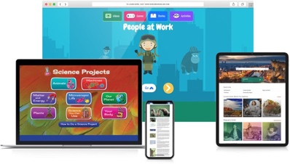

A safe, trusted, 21st-century learning environment for students.
- Homework help
- Read stories, articles, and current events
- Complete activities and Webquests
- Play educational games
- Interactive maps
- Citation builder
- Learn how to do research
- Explore pictures and videos
- Find reliable information for assignments and projects

Encourage Learning Anytime, Anywhere!

Username:
Password:

