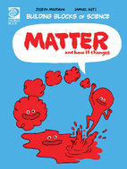
Matter and How It Changes Worksheet
Find under Nature and Science
- What is matter?

- Name the three basic states of matter?

- What causes matter to change states?

- True or false: The state of all matter depends on its temperature.

- True or false: Matter cannot change back and forth between states.

- Why does rain turn to snow?

- What kind of change has a tree gone through to become a piece of a paper?

- If salt in ocean water is mixed evenly and will not settle at the bottom of the ocean, like sand, how do you separate salt from ocean water?

- What kind of change occurs to wood when it is burned?

- Fill in the blanks: Something is changing chemically if it ____________________ or if it is on ________.

- What is an example of chemical change?

- What examples can you think of where you see matter change in your everyday life?

