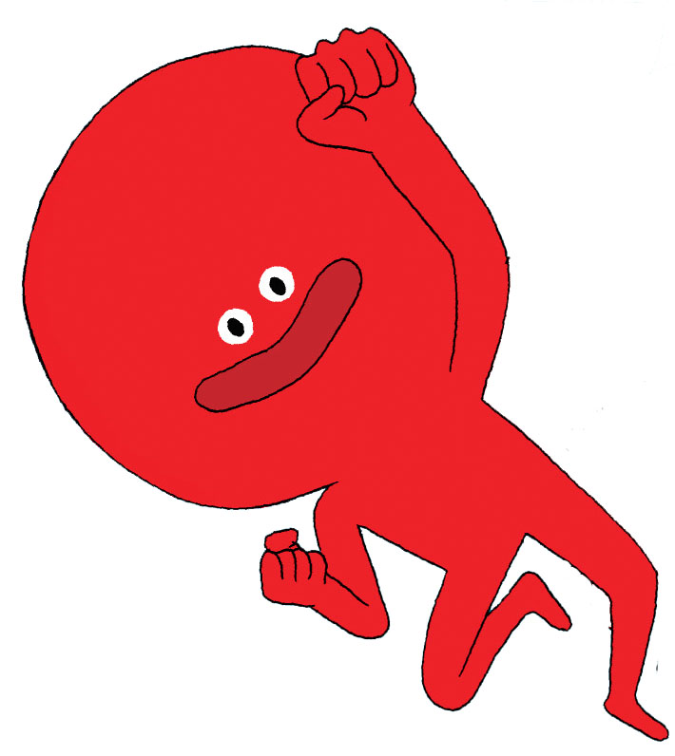
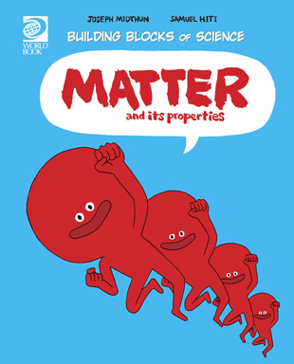

Matter and Its Properties Worksheet
Find under Nature and Science

1. Fill in the blanks:
Matter is anything that has _______________________ and _________________________.

2. What is the centre of an atom called?

3. What are the three states of matter?
1)
2)
3)

4. Match the element with its symbol.
Tin | Cl
Neon | Au
Chlorine | Sn
Gold | Ne

5. Write down what you have learned about matter and its properties.

