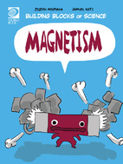
Magnetism Worksheet
Find under Nature and Science

- True or False: Magnetism either attracts or repels.
- True or False: You can stick a magnet to a tree.
- What are some examples of nonmagnetic materials?

- What types of metals are magnetic?

- What affects a magnets pull?

- What are the positive and negative sides of a magnet called?

- What happens to the poles if you cut a magnet in half?

- How does a magnet pull on an object without touching it?

- True or False: The Earth is a giant magnet.
- Where are the magnetic poles on Earth?

- Why does a compass needle always point north?

- What is the relationship between electricity and magnetism called?

- Why do people use electromagnets?

- Explain what magnetism is in your own words.

