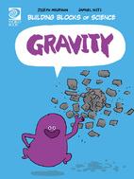
Gravity Worksheet
Find under Nature and Science

- True or false: All objects attract one another.

- What would happen if there was no gravity?

- Fill in the blanks: The strength of gravity depends on __________ and ____________.

- How do we measure gravity?

- True or false: Heavier objects always have a stronger pull of gravity than lighter objects.

- Why would you weigh less on the moon?

- If you drop a hammer or a feather, why does a hammer fall faster than feather?

- What is friction?

- What happens if you drop a hammer and a feather on the moon?

- What stops all planets from crashing into each other?

- How did gravity help form the planets?

- How do black holes form?

