Force and Motion Worksheet
Find under Nature and Science

- True or False: Force is a push or a pull.
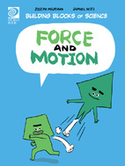
2. Name the different kinds of force.

3. True or False: Motion is not a change in position.

4. What are the two important parts to motion?
1)
2)

5. Why does a heavy boulder move faster than a lighter boulder?

6. What causes a bike to slow down when the brakes are pushed?

7. Name how people use friction?

8. True or False: For an object to move it requires force.

9. Name the six kinds of simple machines.

10. Write down what you have learned about force and motion.

ANSWERS:
1. True
2. Mechanical, Gravity, Magnetism
3. False
4. Speed and direction.
5. The heavy boulder has more mass. The more mass an object has, the more inertia it has.
6. Friction. Friction between the brake pads and the wheel cause the bike to slow down.
7. People use friction to speed up or slow down, and people use it to make heat.
8. True
9. Inclined plane, lever, pulley, wheel and axle, screw, wedge.

