Force and Motion Worksheet
Find under Nature and Science

- True or False: Force is a push or a pull.
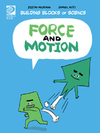
2. Name the different kinds of force.

3. True or False: Motion is not a change in position.

4. What are the two important parts to motion?
1)
2)

5. Why does a heavy boulder move faster than a lighter boulder?

6. What causes a bike to slow down when the brakes are pushed?

7. Name how people use friction?

8. True or False: For an object to move it requires force.

9. Name the six kinds of simple machines.

10. Write down what you have learned about force and motion.

