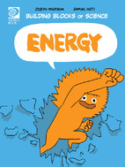

Energy Worksheet

- True or False: Energy makes things move and do work.

- Where does energy come from?

- Name different types of energy.

- What is potential energy?

- True or False: Energy can be created and destroyed.

- Explain how the body changes food into energy.

- How is electric energy created?

- True or False: Once fossil fuels run out, they can be replaced.

- Give examples of renewable energy sources.

- What are the side effects of energy use?

- How can we help reduce our impact on the environment?

- What are biofuels?

