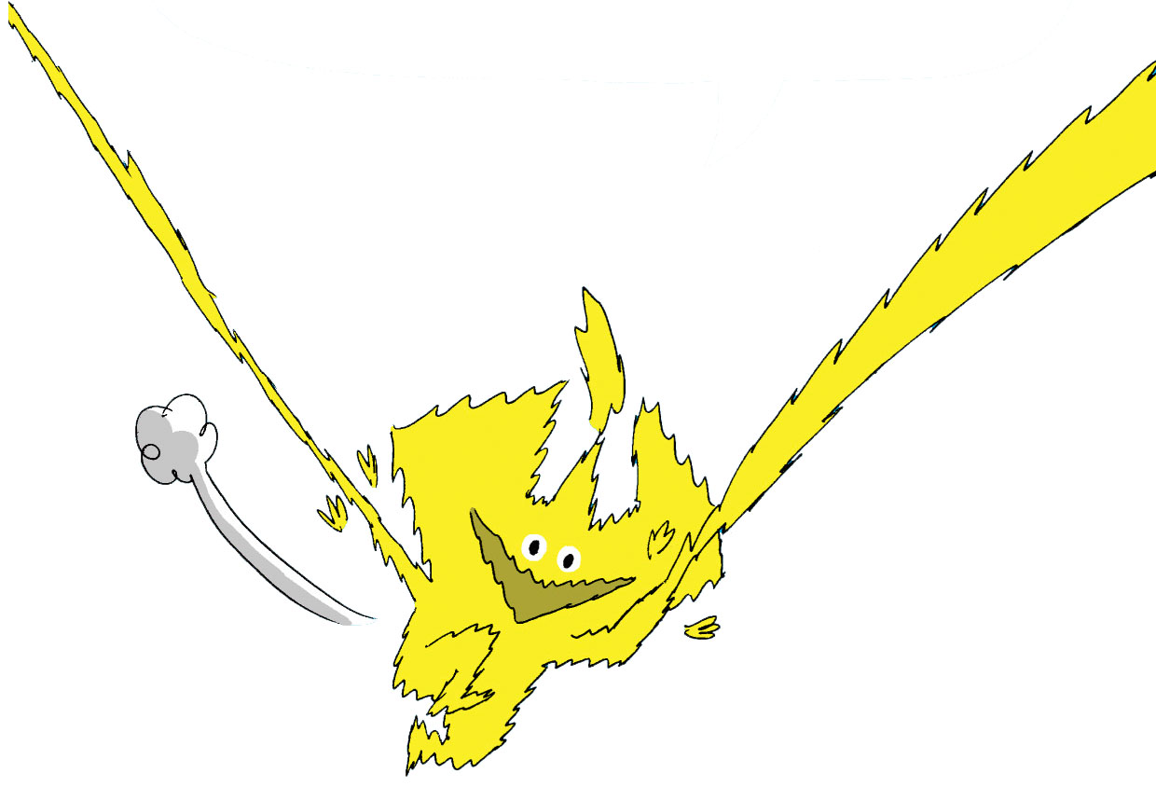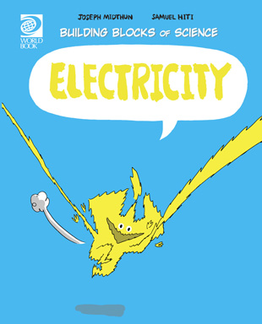

Electricity Worksheet
Find under Nature and Science

1. Name four things that are powered by electricity.
1)
2)
3)
4)

2. What are the three main parts to an electric circuit?
1)
2)
3)

3. True or False: Metals are good conductors.
4. True or False: In the 1900’s people learned to capture electricity and use it to do work.
5. What is one way you can reduce your use of electricity?

6. Explain what electricity is in your own words.

