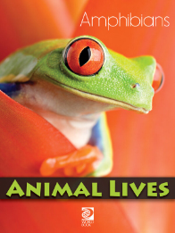
Animal Lives –
Amphibians Activity Sheet
Find under Animals: Amphibians, Reptiles, and Sea Creatures

1. What is the smallest amphibian in the world?

2. Name two differences between reptiles and amphibians.

3. True or False: Caecilians usually spend their entire lives underground.
4. True or False: Amphibians are known for their excellent hearing.
5. Name the three-stage life cycle of a frog.
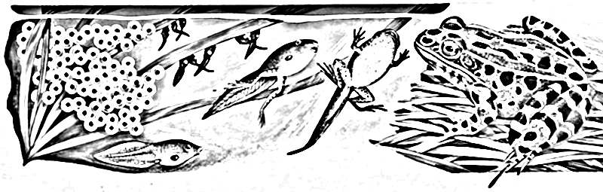
1. 2. 3.
6. What do tree frogs have that help them hold onto trees?
a. webbed feet
b. sticky toes
c. furry skin

7. What fraction of amphibians are endangered?
a. one-fourth
b. one-third
c. one-half

8. Pick your favourite amphibian from the book. What special characteristics does it have?

ANSWERS:

- Tiny gold frog of Brazil
- (i) Amphibians must live at least part of their lives in water.
(ii) Body coverings - reptiles are covered in scales, amphibians do not have scales.
- True
- False – amphibians have poor hearing.
- Egg → tadpole → adult frog
- b. sticky toes
- b. one-third

