British Colonisation of Australia Worksheet
Go to www.worldbookonline.com Click on Student
Type First Fleet in search box in World Book Student. Go to the First Fleet article.
In the First Fleet article scroll down to the section Preparation and answer the question below.
1. Who was in command of the First Fleet and was the first governor of New South Wales?
______________________________________________________________________________
Scroll down to section The fleet and answer the questions below.
2. The First Fleet consisted of how many ships?
______________________________________________________________________________
3. Approximately how many convicts were transported in the First Fleet?
______________________________________________________________________________
Scroll down to section The voyage and First Fleet voyage map and answer the questions below.
4. What date did the First Fleet leave Spithead, Portsmouth, England?
______________________________________________________________________________
5. On the map below fill in the places marked (a), (b) and (c) where the First Fleet stopped during the voyage to Australia.
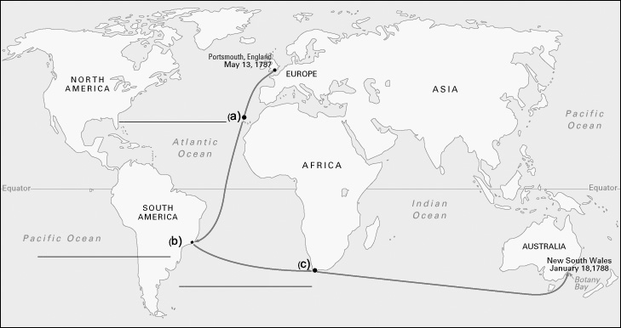
Scroll down to section Botany Bay and answer the questions below.
6. Why was Botany Bay found to be an unsuitable site for the First Fleet to settle?
______________________________________________________________________________
______________________________________________________________________________
7. Where did the First Fleet choose to eventually settle?
______________________________________________________________________________
8. On what date did the First Fleet settle in the new location?
______________________________________________________________________________
EARLY SETTLEMENT
Learn more about the early settlement in Australia by searching History of Australia in the search box.
In History of Australia article scroll down to section The first British settlements and answer the questions below.
9. How were the conditions different on the Second Fleet and Third Fleet compared to the First Fleet?
______________________________________________________________________________
______________________________________________________________________________
10. Why did the settlement's first crops fail?
______________________________________________________________________________
______________________________________________________________________________
11. Where was the first land suitable for farming found, now known as Parramatta?
______________________________________________________________________________
12. How did the new settlement treat the Aboriginal people?
______________________________________________________________________________
______________________________________________________________________________
______________________________________________________________________________
13. What was the name of the disease that killed many Aboriginal people?
______________________________________________________________________________
ANSWER KEY:
- Arthur Phillip.
- 11 ships.
- Approximately 750 convicts.
- May 13, 1787.
- (a) Canary Islands (b) Rio de Janeiro (c) Cape of Good Hope
- Botany Bay was soon found to be unsuitable for settlement, despite the good reports made by Sir Joseph Banks that had influenced the selection of the site as the new penal colony. Fresh water was in short supply in the bay. The bay itself was unprotected against winds, creating a hazard for shipping. The quality of the soil, vital for the growth of the first crops, was poor.
- Sydney Cove.
- January 26, 1788.
- Overcrowding, starvation, and savage punishment inflicted by ships' masters on the convicts caused the high death toll on the Second Fleet and the Third Fleet. There were a small number of deaths during the First Fleet trip.
- The soil around Sydney Cove is sandy and lacks the nutrients plants need to grow causing the first crops failed.

- Rose Hill.
- Some meetings between Aboriginal people and settlers were friendly, and others were hostile. Governor Phillip kidnapped several Aboriginal people and held them at Government House in Sydney. Aboriginal people found themselves hungry and barred from their own lands when the European settlement expanded over the Cumberland Plains.
- Smallpox.

