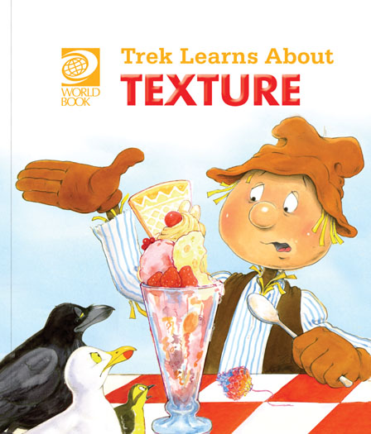
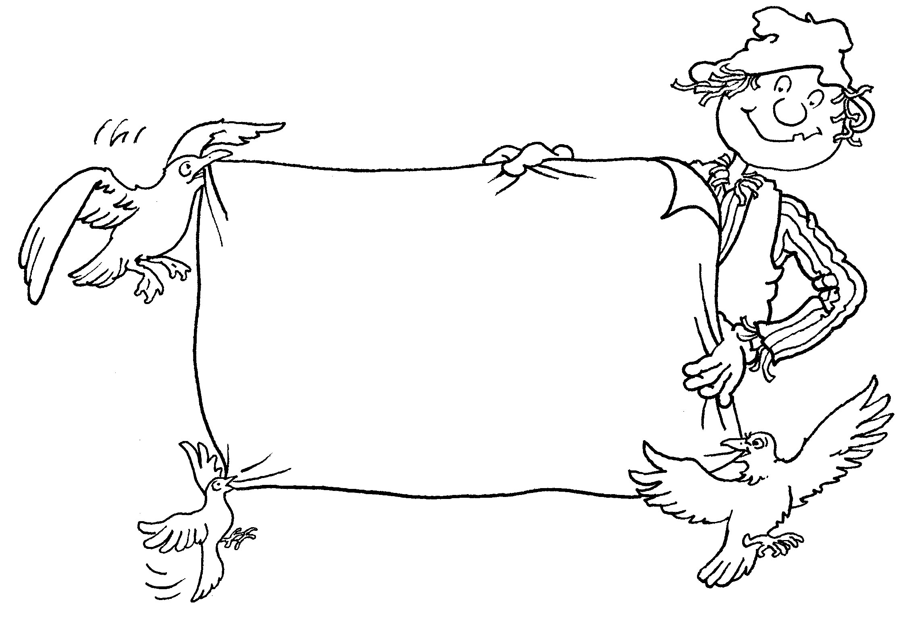
Trek’s Travels –

TEXTURE

All about texture
1. What did Crow eat that was slippery?
_________________________________________________________________
2. Can you remember what food was soft and juicy?
_________________________________________________________________
3. What food did Seagull eat that was crisp and soft and chewy?
_________________________________________________________________
4. Trek had some food that was cold and smooth and creamy – what was it?
_________________________________________________________________
5. What did Wagtail eat that was rough and dry?
_________________________________________________________________

All about food
1. Have you ever eaten an ice-cream?
_________________________________________________________________
2. Was it hot or cold?
_________________________________________________________________3. Can you describe a peach?
_________________________________________________________________4. Is it hard or soft?
_________________________________________________________________

5. Can you think of a crunchy food?
_________________________________________________________________6. Do you know what a pizza is?
_________________________________________________________________

ACTIVITY –
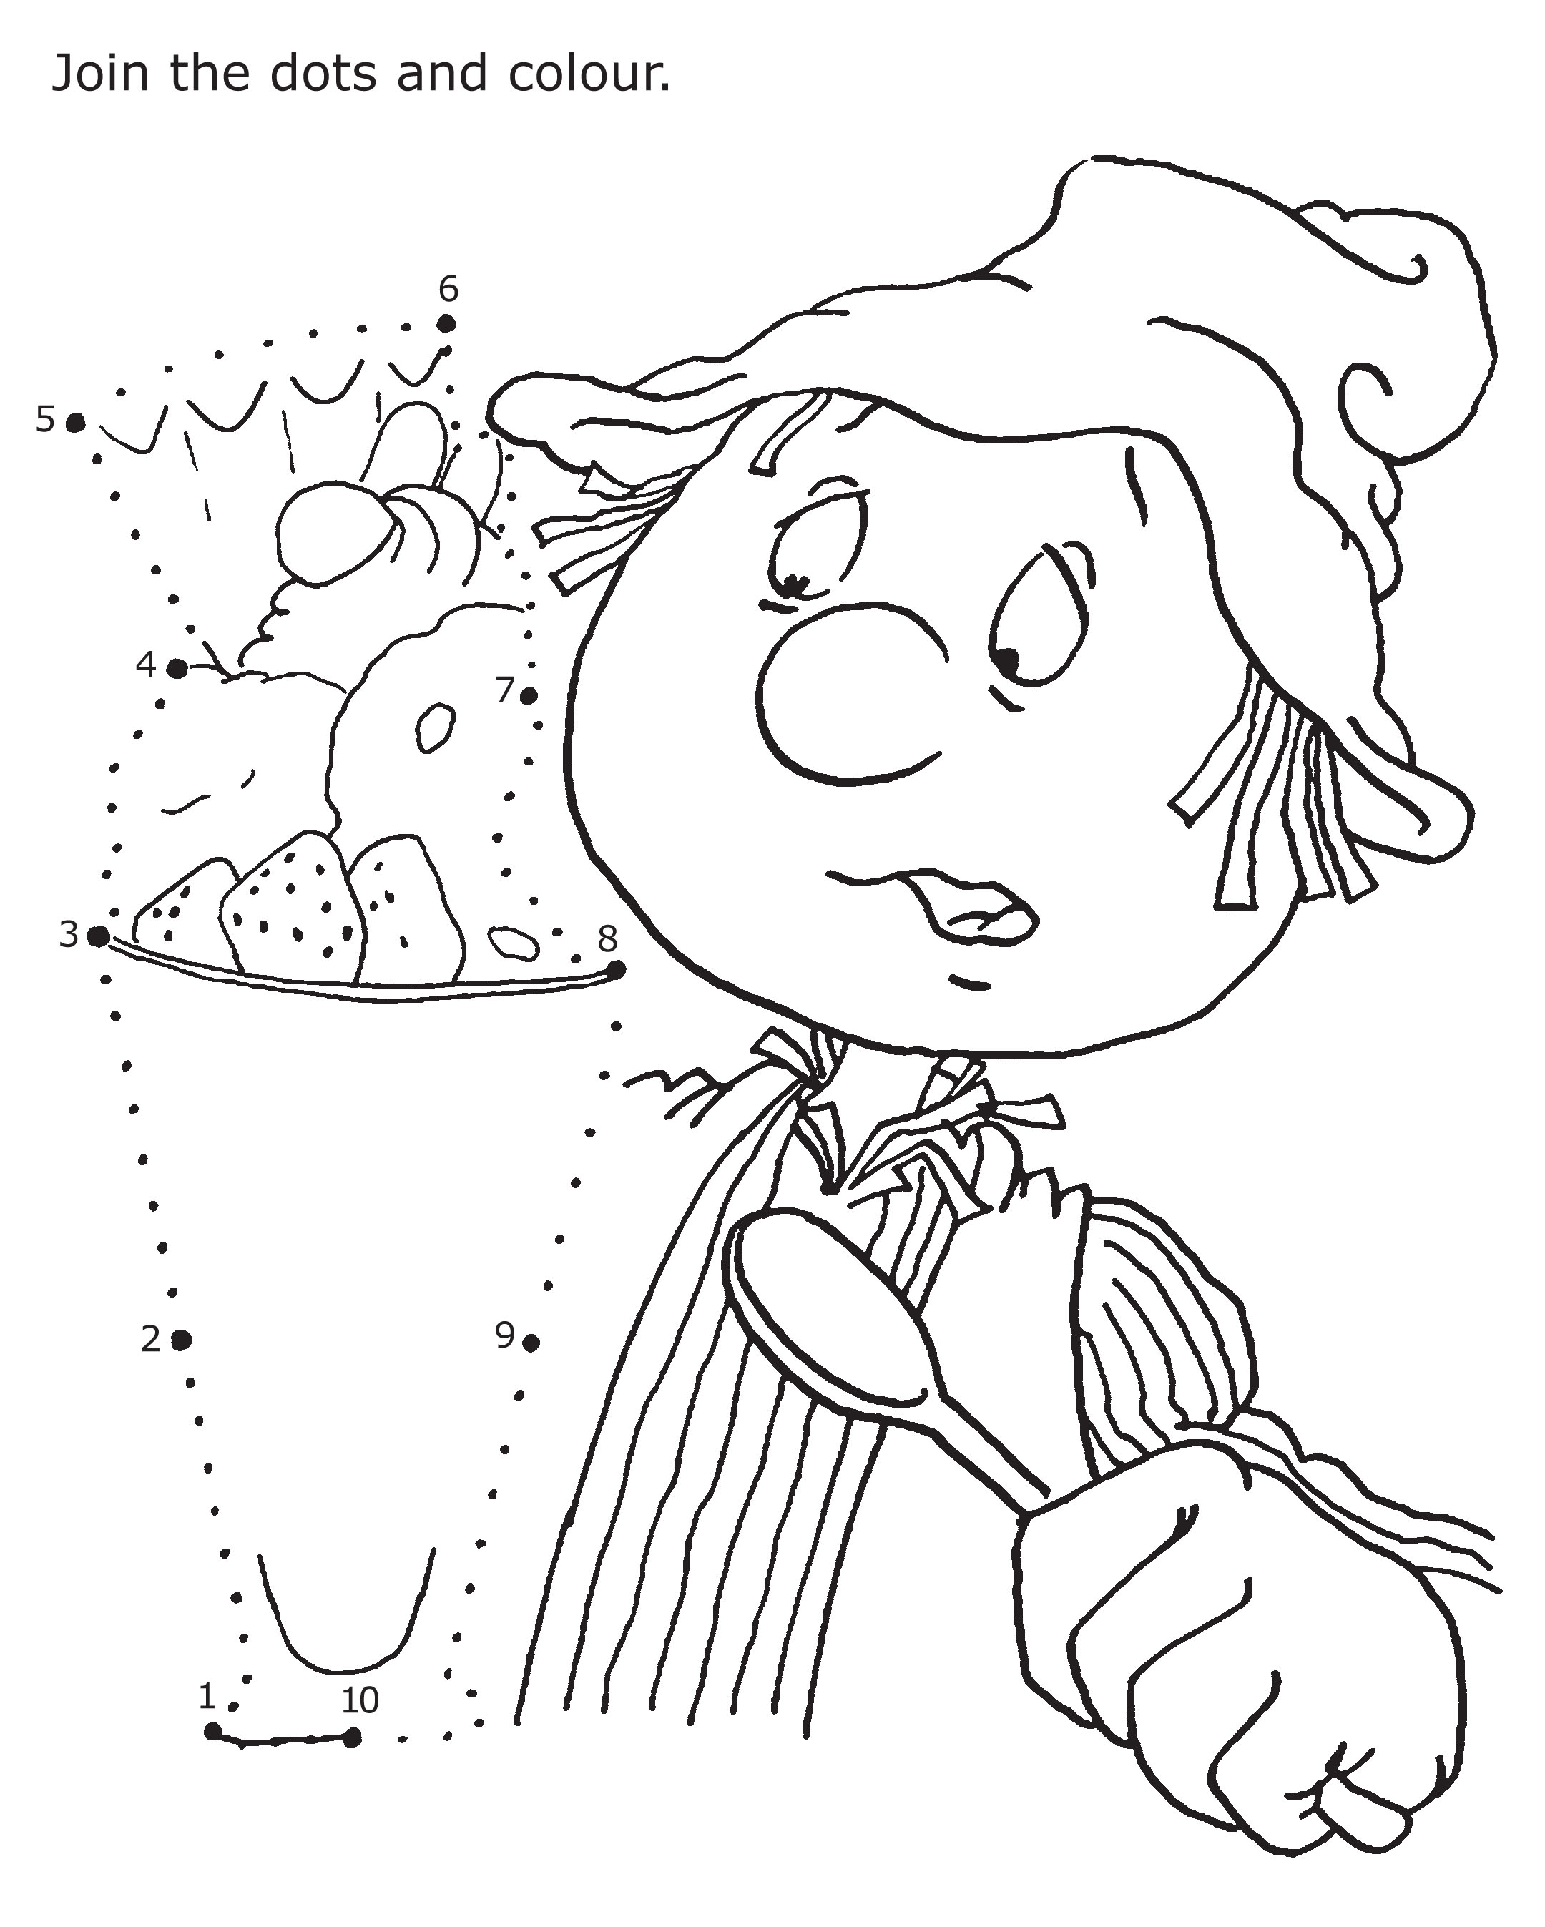
Aim: to practice pencil control and count to ten.
ACTIVITY –

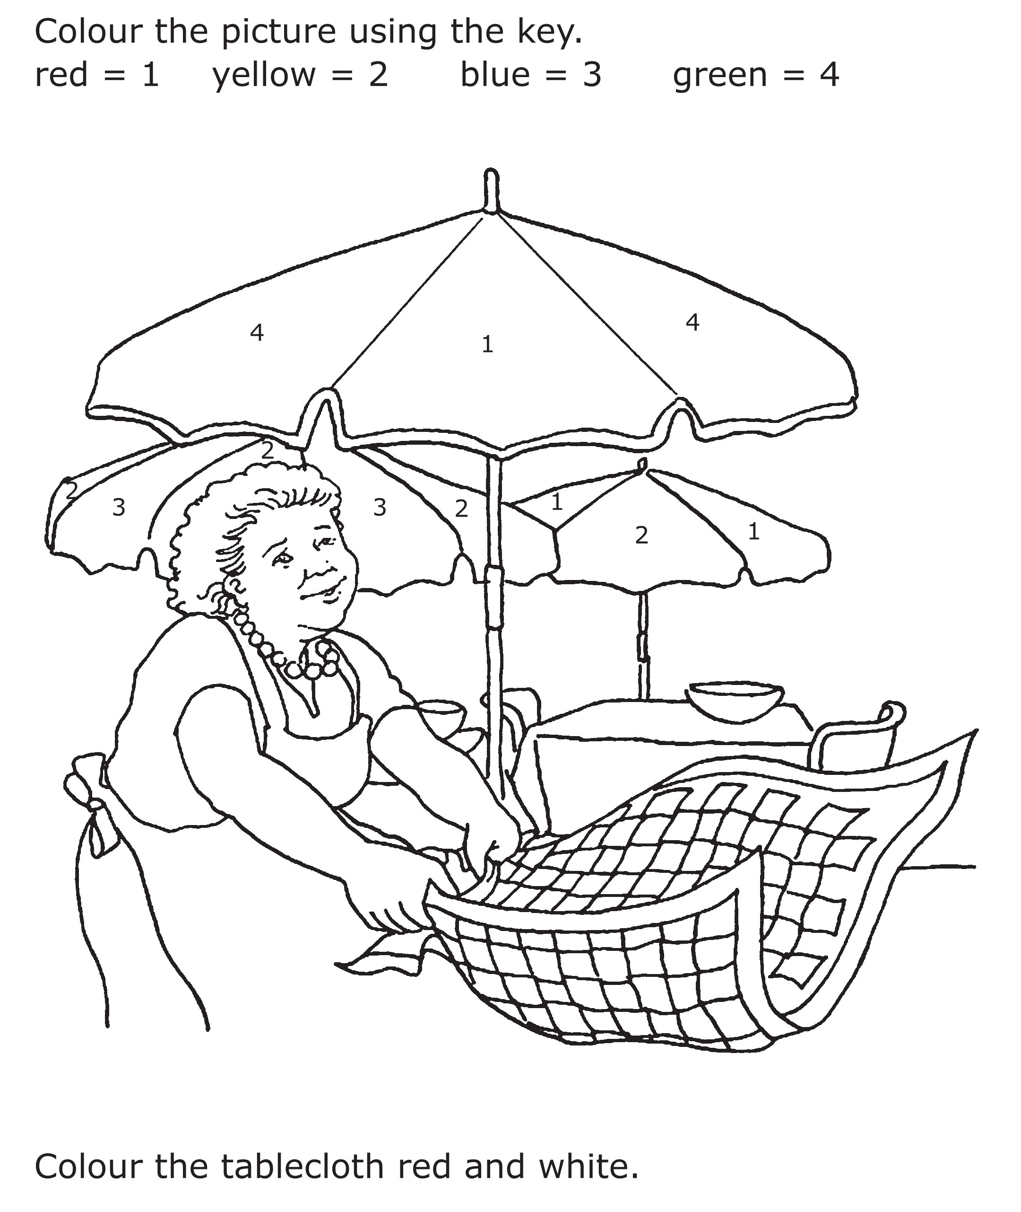

Aim: to recognise colours and follow a key.

Trek’s World Travels
Where in the world does Trek learn about texture?
Italy

