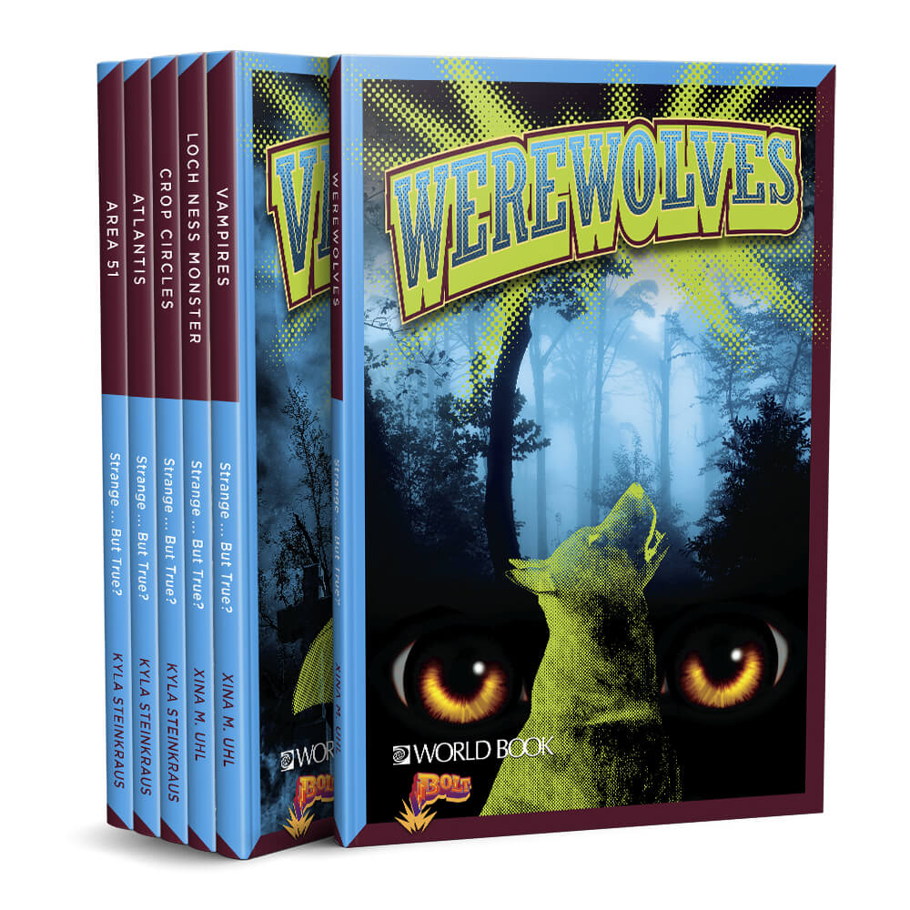
Bolt Strange …. But True
Choose the book from this series that you would like to read. Write your name and class on a post-it note and place it inside the front cover. Don’t choose a book that someone else in your class has already chosen. It doesn’t matter if someone in another class is also using this book.
Tick next to the title you chose from the list below

Tick | Name of Book | Tick | Name of Book
 | Werewolves |  | Area 51
 | Crop Circles |  | Vampires
 | Atlantis |  | Loch Ness Monster

Answer these questions about your book
Look at the Cover
- What is the salient image on the front cover – what do you first look at – the title, the picture, part of the picture, the background, the publisher (World Book) or the series (Bolt). Underline your answer

- Why did you choose that – was it because of its size; position on the cover; colours used. Underline your answer

- What colour stands out the most on the cover of your book?

- Did you choose this colour because: there is more of it than any other colour on the cover; it stands out because it is so bright; it is your favourite colour; there is less of it than any other colour on the cover; it stands out because the background is so dark. You can choose more than one answer. Underline your answer

- Look at the title – does the use of the lime green background behind the title make the title stand out more or less? Underline your answer. What else on the cover uses this lime green colour?

- Lime green is one of the main colours on the cover. Green is a cool colour that makes you think about nature and the natural world. How does this fit in with the series heading: Strange … But True?

- Lime green can also make you feel: calm, healthy, jealous, confident, as though lots of things are going to happen. How do you feel about your book when you look at the lime green on the cover? Underline your answer or add another feeling that isn’t there.

Look at the spine of the book
- What is written on the spine?

Look at the back cover of the book
- Read the blurb. “The world is full of mysterious stories of hairy creatures and aliens from outer space.” What hairy creature that may or may not be real, have you heard about?

- Have you watched a movie about an alien from outer space? Yes/no. Underline your answer. If you answered Yes – what was the movie called?

- “But are the stories true? The answer is up to you.” The blurb asks you a question – whether what is in your book is true or made up. What do you think – is your book going to be about something real, but true? Or the book is going to be about something that is not real, is made up – a fantasy. Underline your answer.

- Underneath the blurb there are the picture of 6 books in the Strange …. But True series. Which cover do you think stands out the most? Why?

- Five of the covers are mainly blue and green. What is the title of the book that has a different main colour in the background?

Turn to the title page of the book.
- Who is the author of your book?

- Is the style of the title the same or different to the title on the cover? Look at the shape of the background behind the title. Underline your answer

Look at the Glossary (page 30)
- Choose one of the words from the Glossary that you didn’t know the meaning of – write it down, with its meaning.

Look at a double page spread in your book where the picture goes over both pages and there are only labels, not sentences.
- What is the number of the two pages you are looking at?

- Do you need to turn the book around to look at this double page spread? Is the orientation of the page here Portrait Mode or Landscape Mode? Underline your answer. (Portrait is taller rather than wide; landscape is wider rather than tall.)

- What is the salient image on this double page spread? Why does it stand out more than anything else?

- What is the title of this double page spread?

- Look at the modality of the picture on these 2 pages. Modality means how realistic a picture looks. High modality looks like it is a photograph, that it is real. Low modality means it looks like a cartoon, or a line drawing. Is your picture high modality or low modality? Underline your answer.

- Angles are often used to convey point of view.
- If you want to make something look big, powerful or strong you look upwards at it, as if you are lying on the ground looking at something which is towering above you. This is called low angle.
- If you want to feel equal or the same as something, you look at it from eye level angle.
- If you look at something from a high angle, you are looking down on something, you are looking at it from above. This makes the person or object look small or weak.

Is the picture on your page looked at from a high angle, a low angle or from an eye level angle? Underline your answer.

- Vectors are real or imaginary lines on the page. They make our eyes follow a certain path on the page. This is called the reading path. On this page, what type of lines and shapes are used to make our eyes look at certain things? Choose from: straight lines, curved lines, dotted lines, different coloured lines, circles, arrows, squares. Underline your answer(s).

- Read the book
Write down an interesting fact you learned in this book.

- Look at Pages 28-29. Do the Quiz. How many points did you earn? _______ Are you a believer in the subject of your book or a non-believer. Or are you still not certain whether it is true or not. Underline your answer.

