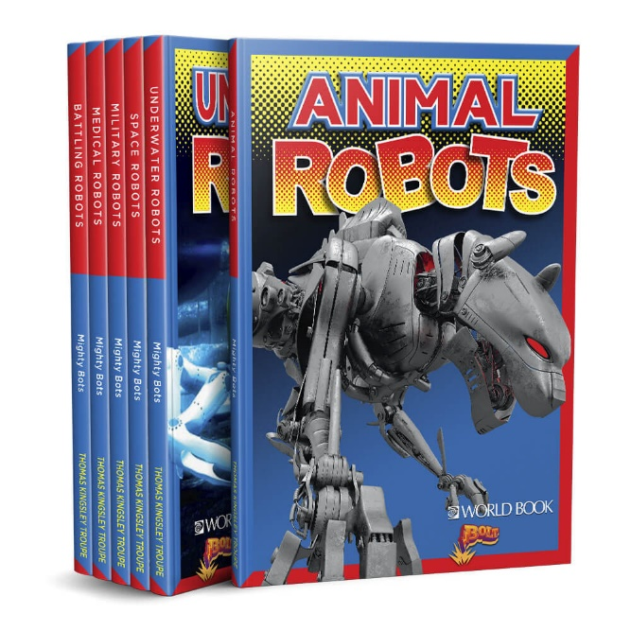
Bolt Mighty Bots
Choose the book from this series that you would like to read. Write your name and class on a post-it note and place it inside the front cover. Don’t choose a book that someone else in your class has already chosen. It doesn’t matter if someone in another class is also using this book.
Tick next to the title you chose from the list below

Tick | Name of Book | Tick | Name of Book
 | Space Robots |  | Underwater Robots
 | Military Robots |  | Battling Robots
 | Animal Robots |  | Medical Robots

Answer these questions about your book
Look at the Cover
- What is the salient image on the front cover – what do you first look at – the title, the picture, the publisher (World Book) or the series (Bolt). Underline your answer

- Why did you choose that – was it because of its size; position on the cover; colours used. Underline your answer

- What colour stands out the most on the cover of your book?

- Did you choose this colour because: there is more of it than any other colour on the cover; it stands out because it is so bright; it is your favourite colour; there is less of it than any other colour on the cover; it stands out because the background is so dark. You can choose more than one answer. Underline your answer

- Look at the title – does the use of the spotty background behind the title make the title stand out more or less? Underline your answer.

- Look at the colours chosen for the title – what are they? What do those colours make you feel – excited, hot, cold, energetic (that lots of things might happen in this book), dull or bored. Underline your answer

Look at the spine of the book
- What is written on the spine?

Look at the back cover of the book
- Read the blurb. “Robots have starred in TV shows and movies for years!” What shows or movies have you watched that have a robot in them?

- Robots “are amazingly helpful …… and amazingly fun.” Amazingly is repeated in this sentence – why do you think they did this? Does it make it seem more important, more amazing, than if they had only written amazingly once? Yes/no. Underline your answer.

- What do you think the dots (ellipsis) in that sentence are for? How do they affect your reading of the sentence – do you slow down or go faster. Underline your answer. Does the use of the ellipsis make it a bit more mysterious or not (you’re not quite sure what is going to happen)? Yes/no. Underline your answer.

- Underneath the blurb there are the picture of 6 books in the Mighty Bots series. Which cover do you think stands out the most? Why?

- Look at the images on each of the 6 books - what is similar about them? Think about: size/ can you see all of the picture or only part of it/ the robots are very mysterious or different. Underline your answer.

Turn to the title page of the book.
- Who is the author of your book?

- Is the style of the title the same or different to the title on the cover? Look at the shape of the background behind the title. Underline your answer

- Look at the shape behind the title carefully. How does it fit in with the series heading, Bolt? What does it remind you of?

Look the Table of Contents
- What is the salient image on this page?

- What is the background colour on this page? What images can you see in the background?

- How many chapters are in your book?

- Which chapter are you most interested in reading? Why?

- Which page do you need to turn to, to read this chapter that you are the most interested in?

Look at the Glossary (page 30)
- What is a glossary – what does it tell you?

- Choose one of the words from the Glossary that you didn’t know the meaning of – write it down, with its meaning.

- Next to each word in the glossary there is another word in brackets – for example – recreational (rek-ree-EY-shuh-nl). What does this word in brackets do?

- Why is part of the word in brackets written in capital letters (EY) but the rest an in lower case letters? How does this help you say the word?

- The word in brackets is broken down into syllables – how many syllables are in recreational?

Look at Learn More (page 31)
- Under Books, there are 3 books listed. These are books that you might also like to read that are about the same topic as the book. Which title would you like to look at from this list?

- Under Websites, there are 3 different websites listed. These are places on the internet that you might also like to go to, that are about the same topic as the book. Which website would you like to look at from this list?

Look at the book
- Write down an interesting fact you learned in this book.

