Wood
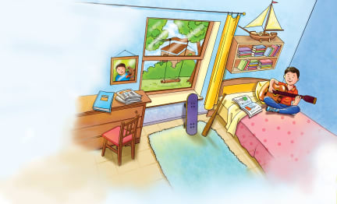 | Wood comes from the _________ and branches of trees. People work with wood to make everything from ____________ and tables and chairs to musical instruments and baseball bats.
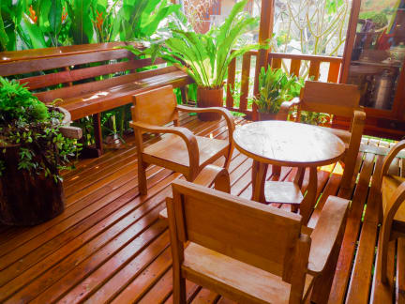 | Wood grows under the __________ of trees. Wooden ________________ and flooring are made from trees.
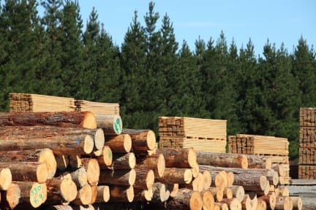 | Loggers cut down millions of trees in the world’s _______________. Logs from these trees are cut into ____________. Lumber is used for _______________ and many other things.
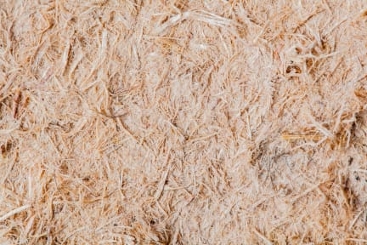 | Paper is made from wood pulp. _____________ is ground up wood mixed with ______________.
 | Many musical instruments, including ______________, are made from wood. Most ______________ have a wooden case.
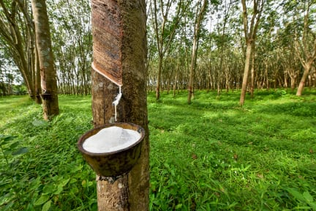 | Natural ______________ is another important thing we get from trees. Rubber is made from ___________. Latex is a milky juice produced by the rubber tree.

