What are trees?
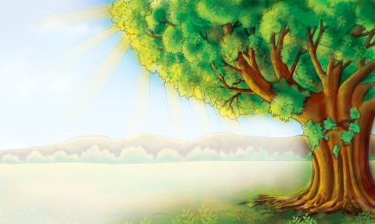 | Trees are the world’s largest ___________. Plants are living things that grow and live in one _________ and do not move around. Like other plants, trees need water and ______________ to grow. Trees take up __________ from the ground through their ____________. The leaves of a tree use sunlight to make _________. The food helps the tree to grow.
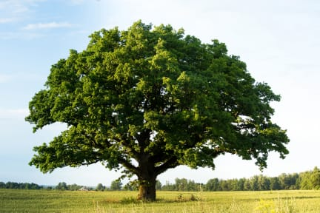 | The ____________ is made up of the tree’s branches and leaves. Branches grow out from the ____________ of the tree and give a tree its shape. ____________ use sunlight to make food for the whole tree.
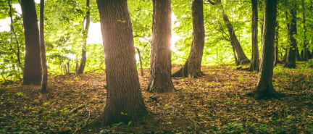 | A tree has a large, woody stem called a ___________. The trunk is strong enough to stand by itself and support the ______________.
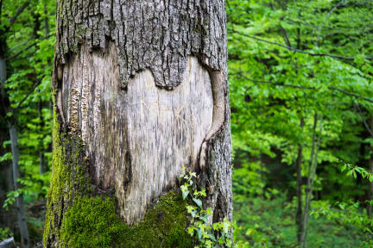 | ___________ is the hard covering that protects a tree’s trunk, ___________, and branches. __________ is under the bark.
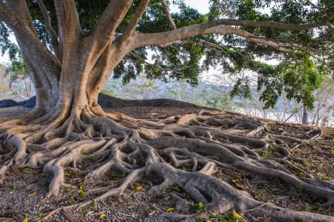 | A tree’s _____________ grow down into the ground. They carry __________ from the soil to the tree. The roots can be as ______ as the tree’s trunk and crown that we see.
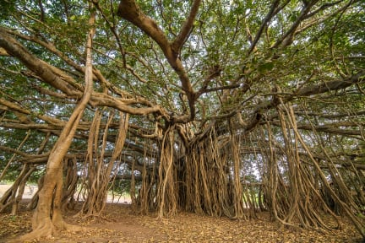 | A banyan tree can look like a small _________________. It has many ___________!

