Utility Workers
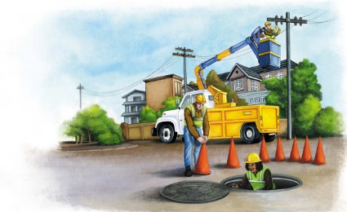 | Utility workers perform many important services. Some help to bring clean ___________ to our homes and remove wastewater. Others provide natural _______ to heat homes and power stoves. Still others provide __________________ service.
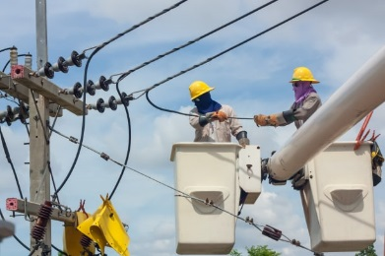 | Utility workers use special equipment to reach __________ high in the sky. They use special tools to work on a __________ _________. A hardhat protects the electrical worker’s __________ in case of a fall.
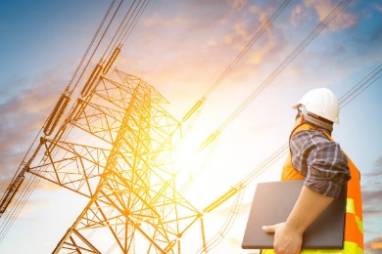 | Power lines are wires that carry __________________ across cities and towns. Utility workers must be careful when working around electric power __________.
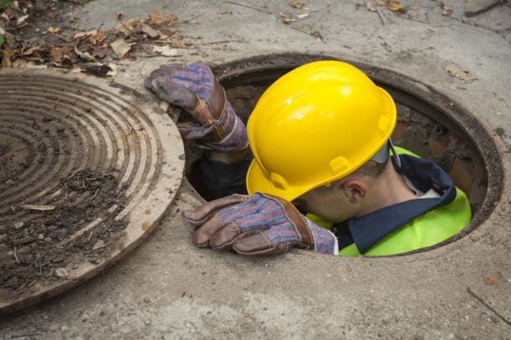 | A __________________ allows utility workers to get to underground wires.
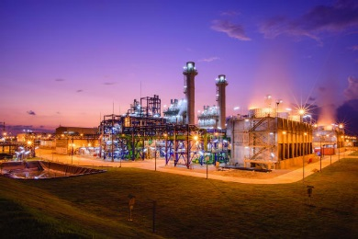 | Electric power is made in buildings called __________ ___________. Power lines go from the plants to buildings and houses.
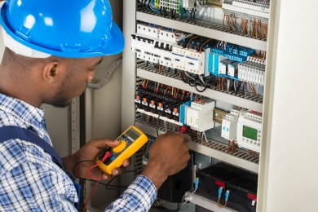 | An ____________________ must have more knowledge of electricity than an electrical worker. Electricians understand architects’ drawings and _________. Architects are people who design buildings. Physics is the study of matter (what things are made of) and ____________.

