Truck
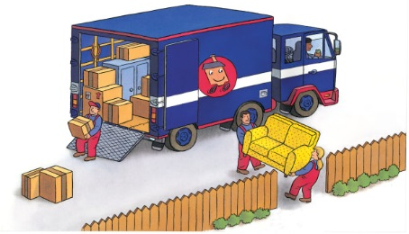 | Trucks come in different shapes and _________. They rumble down roads, moving all kinds of heavy loads from place to place. Trucks can deliver ice-cold _______ and fresh bread to a shop or take your furniture to a new _________.
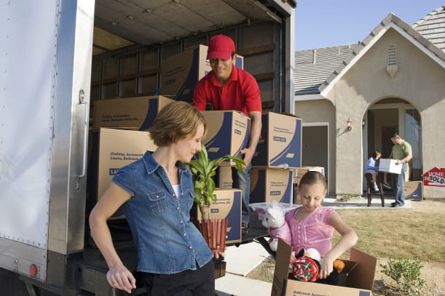 | There is plenty of space inside the __________ to pile up your belongings.
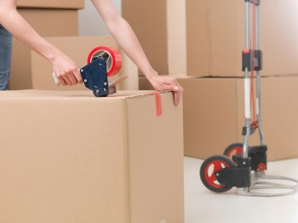 | Packing things in _________ keeps them safe.
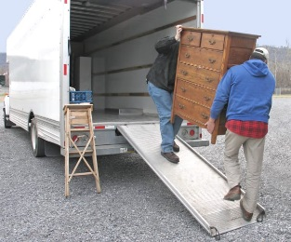 | Movers walk up a ________ to load furniture into a moving van.
 | A sofa is a heavy _________. It is hard work carrying it to the house!
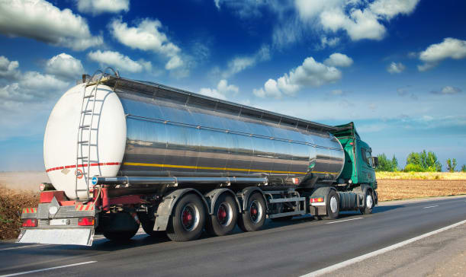 | This long truck carries _______ in a huge, shiny container. The driver travels for days to deliver the load.

