Trees with Needles
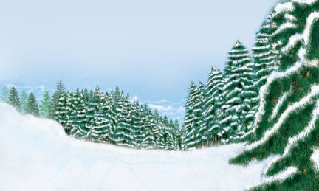 | Some trees have small, narrow pointed leaves that look like _______________. These trees are known as _____________________ trees. They include firs, ________, redwoods, and spruces. Many needleleaf trees grow in __________ areas. They keep their needles all year around, even during ____________-.
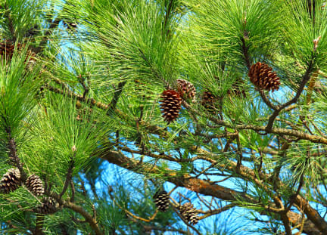 | Needleleaf trees do not grow _____________ or fruit. Many of these trees have seeds in woody ____________. The seeds are spread by the _________.
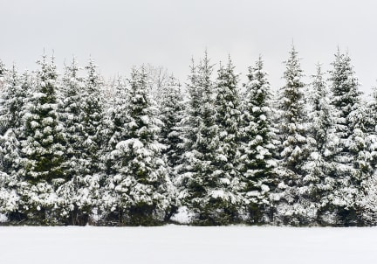 | Most needleleaf trees are ___________________. Evergreen trees stay green all __________ long, even in the snowy winter. These leaves do not drop off in the _________________.
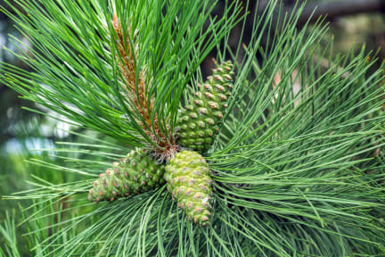 | Nearly all ___________ trees have needle leaves that grow in bundles.
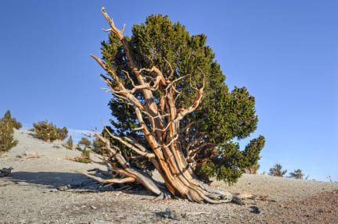 | California’s brstlecone pines are among the ______________ trees in the world. Some bristlecone pines have lived between 4,000 and ___________ years!

