Trees with Leaves
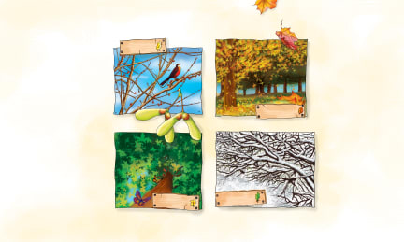 | Many trees have wide, flat _____________. Ash, elm, maple, and oak trees are called _________________ trees. In the ___________, their leaves turn bright colours and fall off. The trees rest during the winter. In the ___________, they come back to life, growing new leaves, flowers and ___________.
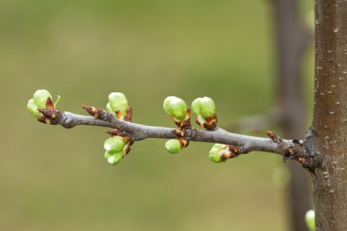 | ________ grow into leaves or ________________ in the spring. Some trees have tiny flowers that you might not even notice.
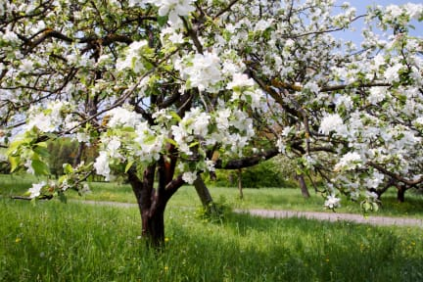 | Apple trees have beautiful flowers that open in the spring. Flowers grow into _____________ that hold _______. Seeds grow into new ____________.
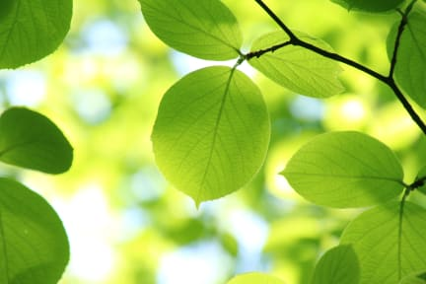 | In the _______________, leaves make food for trees to grow tall. Almost all leaves are _________ in the spring and summer. Leaves come in different sizes and ____________.
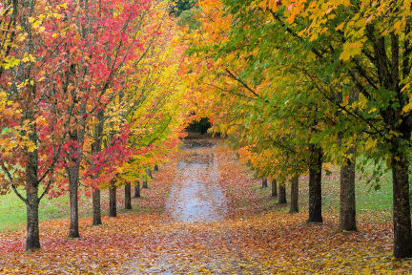 | Leaves turn beautiful colours and fall off in the ______________. After the leaves fall, they become part of the __________ and support the new plant growth.
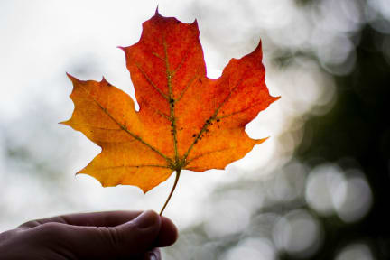 | The maple _______ is a symbol of the country of Canada. A red maple leave is on the Canadian _________. Canada makes most of the world’s maple ______________.

