Tree Ferns
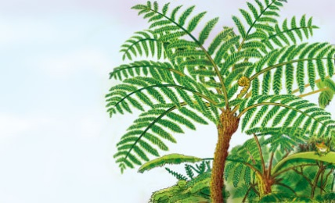 | Ferns are plants with _______________ green leaves. Many ferns are ___________. But some grow into trees. Many kinds of tree ferns grow in __________ places called ___________ _______________ that get plenty of rain.
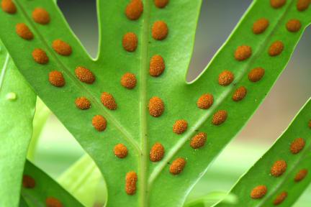 | Tree ferns do not make flowers or ____________. New plants grow from tiny _____________. The spores grow on the bottom side of a fern’s _________________. The spores fall to the ground and start new plants.
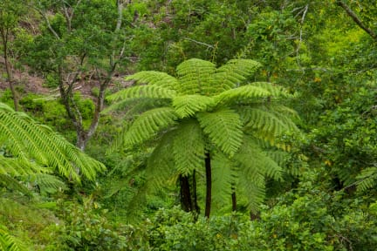 | A large fern leaf is called a ______________. Fern leaves make _________ for the plant.
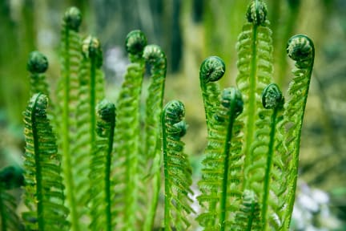 | Young fern leaves are called _____________________. The fiddleheads are ________________ like the top of a violin. They ___________ as they grow.
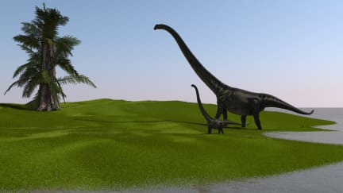 | Ferns grew in the great _________________ millions of years ago. They grew long before the ______________________ appeared on Earth.

