Train
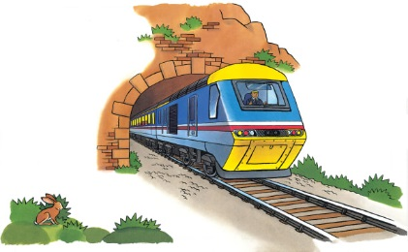 | All day long, _________ hurry from town to town. They stop at _____________ along the way to let people on and off. A train moves quickly, racing past fields, over __________, and through deep, dark tunnels.
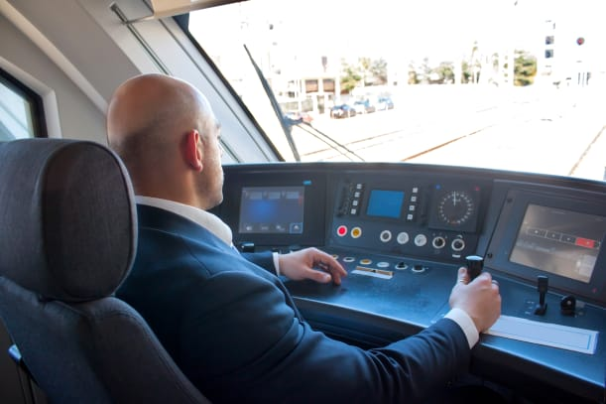 | The ________________ moves levers to make the train __________ up or slow down.
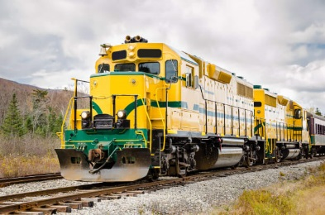 | A powerful ___________________ pulls or pushes the train forward. Bright lights help the __________ see ahead and let people know the train is coming.
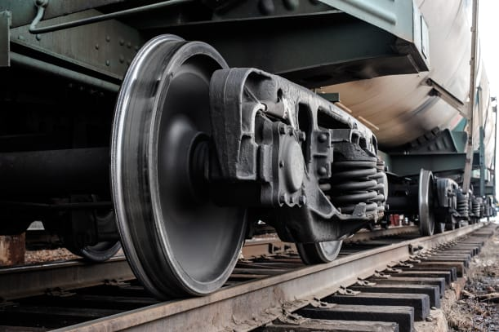 | A train rolls along two shiny rails called ____________ __________. Wheels with special edges keep the train on the track.
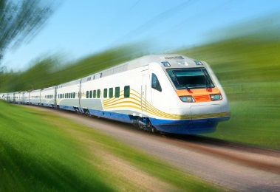 | Passengers sit in _______________ that are hooked together in a long line.
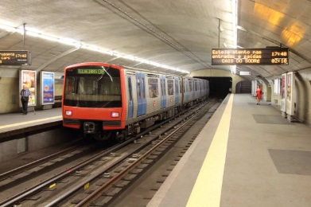 | Underground trains, sometimes called ______________ trains, shoot through ______________ far beneath a big city.

