Tractor
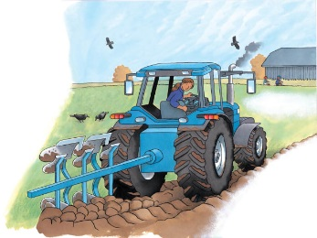 | On a _________, a tractor helps with lots of jobs all year. It pulls or pushes heavy equipment through ___________ and over rugged ground. Depending on the season, a farmer may use a tractor to _________ a field, cut or carry ________, or even pick fruit.
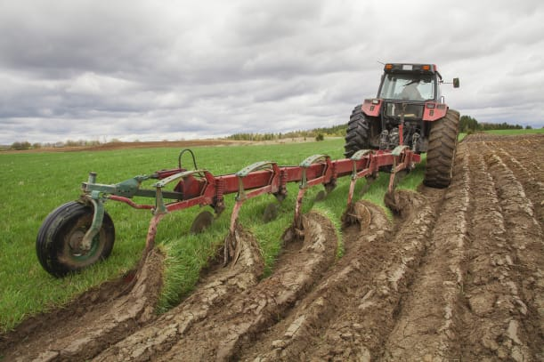 | This tractor is pulling a ___________. A plow digs up hard soil so that seeds can be planted.
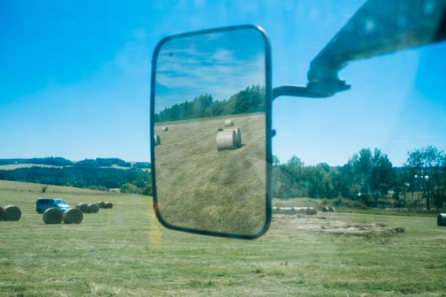 | Big side ____________ helps the driver see all around the big truck.
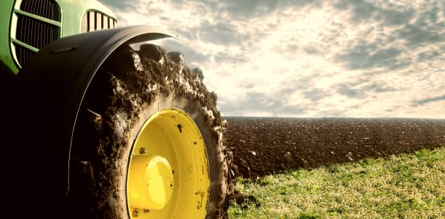 | Thick ________ help the tractor move easily through muddy fields. A mudguard stops ________ from splashing into the driver’s cab.
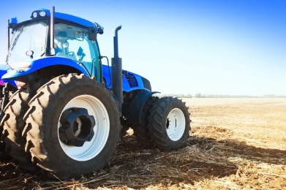 | A tractor’s rear _____________ are big to keep the tractor steady. The front wheels are small to make steering easier.
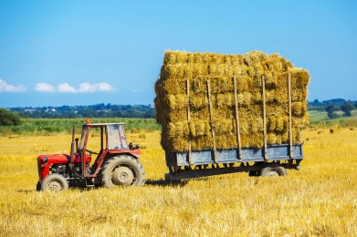 | This ____________ is hitched to a tractor. The trailer is piled high with ________ for animals.

