Touch and Feel
 | Does a feather feel ________ or hard, smooth or rough? You find out how things feel by touching them. Your ________________ are best for touching but toes are good, too. This picture shows lots of things you can find on a beach. Can you imagine how they feel?
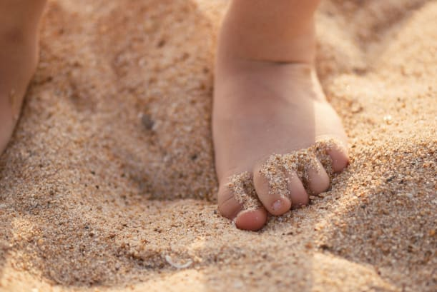 | When you dig your feet into _________, the tiny grains tickle between your _________.
 | Rock is hard and jagged. It feels ___________ against your bare skin.
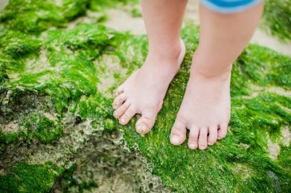 | Seaweed feels ____________ when it’s wet. Don’t slip!
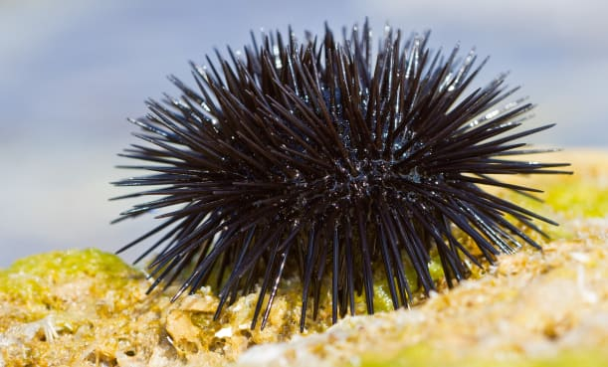 | Keep away from a sea urchin or it will sting you with its ____________ spines!
 | This boy loves his pet dog. He presses his face against the dog’s soft, __________ coat to give it a big hug.

