The Gingko Tree
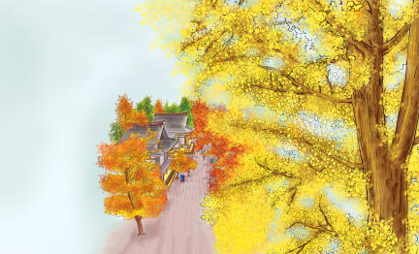 | The gingko tree has ____________ that look like small hand fans. Some people in the countries of ___________ and Japan think of ginkoes as very special, or __________, trees. They plant gingkoes in the gardens of their ____________. Temples are places where people _________. Some gingkoes alive today may be more than _____________ years old.
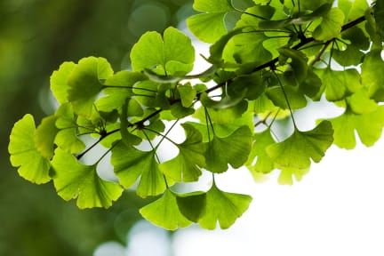 | Gingko ________________ are shaped like fans. They grow in _____________ at the end of short stalks.
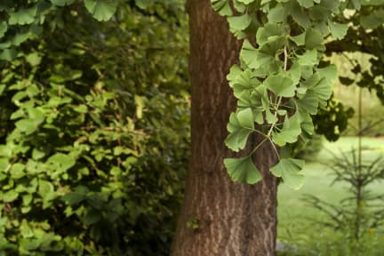 | The trunk of a gingko tree is covered by brown _________. Gingko trees are planted along the _______________ in many countries as decoration.
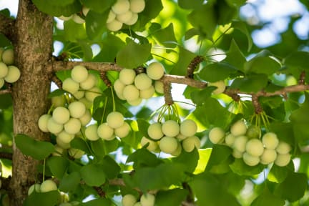 | Gingko trees produce round ___________ covered by yellow to orange flesh. People ___________ and eat what is inside the gingko seeds.
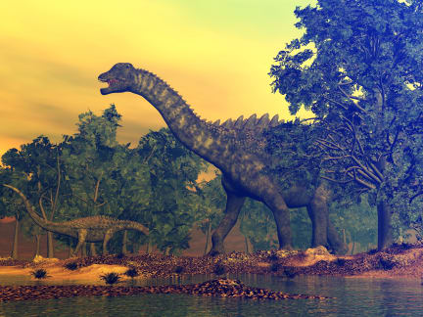 | Gingko trees lived _______________ of years ago. Many ____________________ probably munched on the leaves of these trees for food.

