Teacher
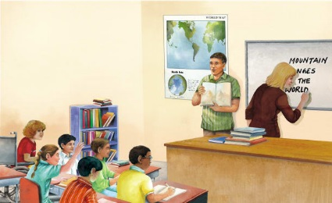 | Teachers help us __________. Some teachers work with _________________. Others help adults learn.
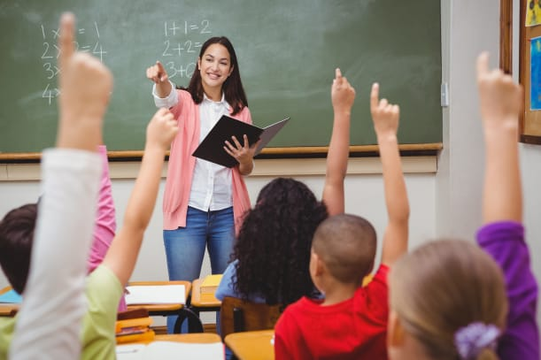 | Students raise their __________ to answer the teacher’s question.
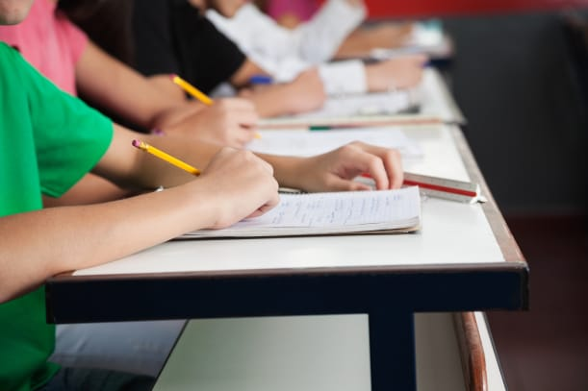 | Students use _________ and paper to take notes.
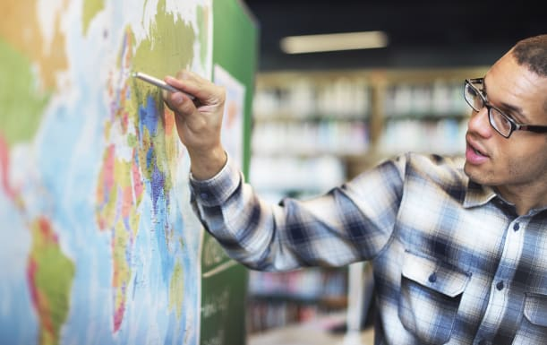 | A _________ helps us find different places around the world.
 | A teacher writes lesson on a ______________________.
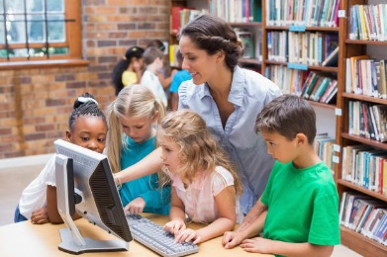 | Librarians work in a school or ________ _________________. They help people find and use ___________________.

