Taste and Smell
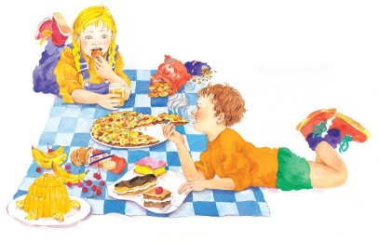 | Your ______________ does a special job. When you eat, it tells you if you food tastes nice or yucky. Your _________ helps, too, by catching smells that float into the air. The smell of fresh popcorn or hot pizza can make you feel really _______________.
 | Licking ice cream makes your _____________ tingle. It feels ________ in your mouth and tastes yummy!
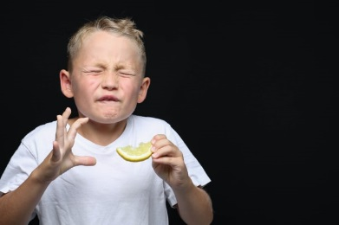 | Lemons taste so _________ that eating them makes your face pucker!
 | Cookies and cakes are baked with lots of sugar to make them taste ____________.
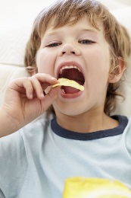 | Salty chips and peanuts can make you _______________.
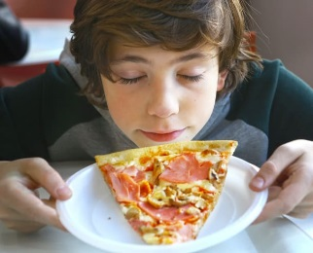 | Steaming hot pizza ___________ so good that you can’t wait to eat.
What are some of your favourite tastes and smells? | ________________________________________  ________________________________________

