Staying Well
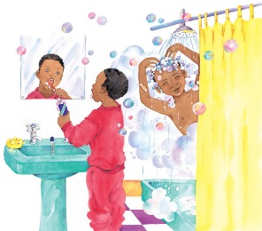 | Your body is a wonderful machine. Just think of all the things it can do. But you must take care of it to stay _______________. You need plenty of ______________, water, fresh food, and sleep. You need to __________ every day to keep yourself clean!
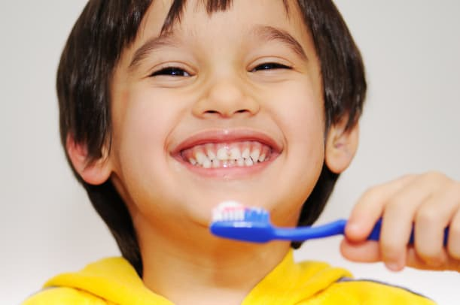 | Brush your ___________ with toothpaste to help them stay clean and ___________.
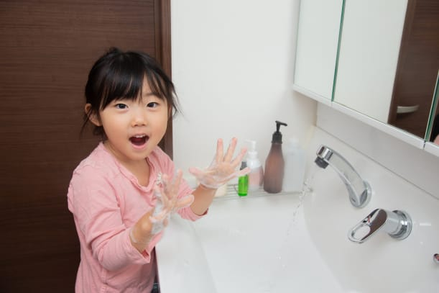 | ___________ is for washing your ________. You rub it all over even behind your ears!
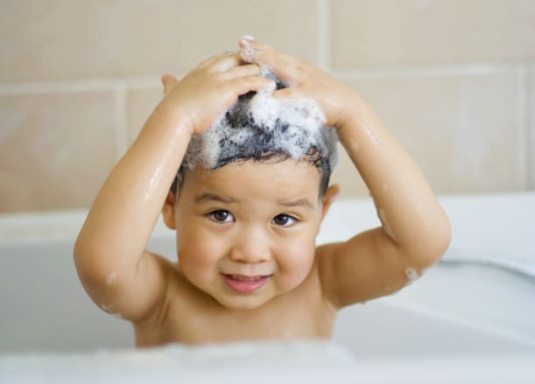 | ___________________ gets rid of dirt in your __________ and makes lots of bubbles, too!
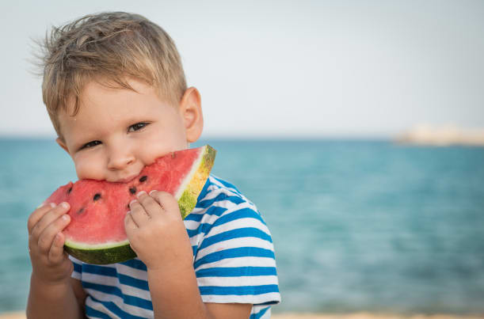 | Fresh __________ is tasty and good for you, too. It helps your body __________.
 | Playing can tire you out. A short _______ gives your body a ________, so you are ready to start all over again.

