Snowplough
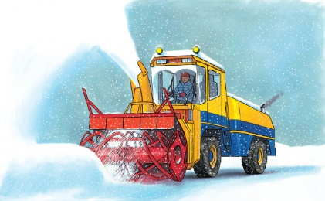 | When lots of _______ falls, it can block busy roads and railroad tracks. It may even stop you from going to school! A __________________ makes a ________ through the deep snow so that traffic can move safely again.
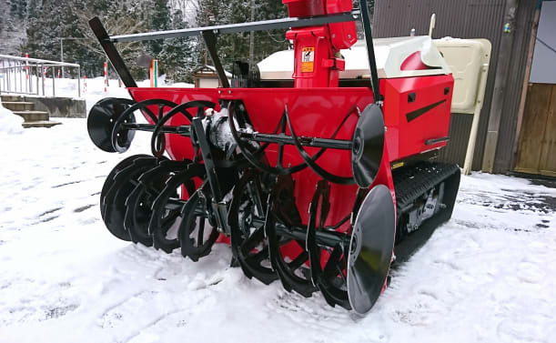 | Some snowploughs have _________ that spin around and around. They pull the snow out of the drifts and into the __________.
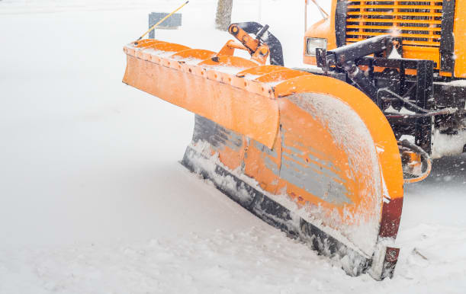 | Some snowploughs have one huge, curved ________. The blade pushes the snow to the ________ of the road.
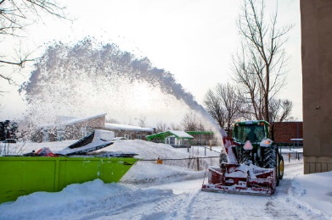 | A long ____________ blows the snow far away from the road.
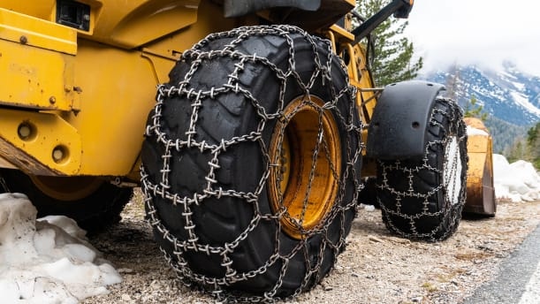 | Strong __________ grip the slippery road. They stop the __________ from skidding.
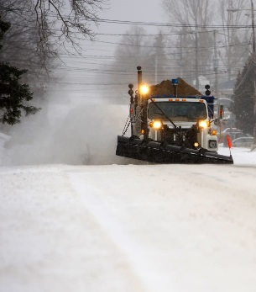 | Bright ___________________ help the driver to see ahead.

