Snake
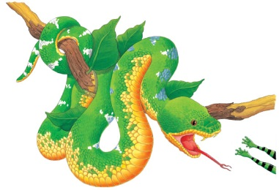 | Snakes _________________ across the dark forest floor and climb trees. The emerald tree _______ in the big picture is hanging from a branch, ready to pounce on a tasty ________ snack. After a really big meal, it may not eat again for a ________!
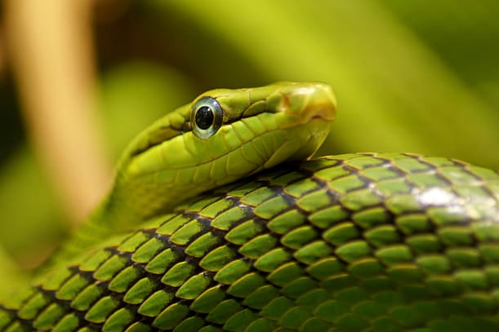 | A snake’s body is covered in smooth or rough _________. The scales help the snake ________ slippery branches as it moves along. The ___________ of some snakes’ scales make them hard to _______ among the leaves.
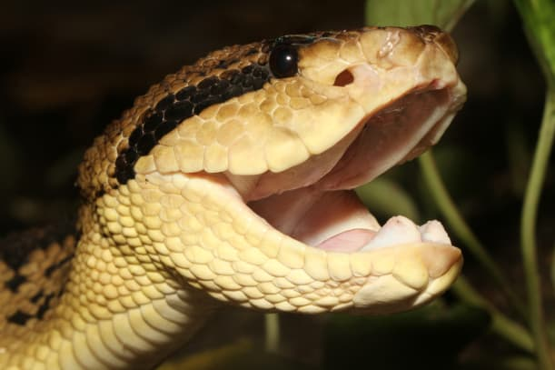 | A snake has flexible ________. The jaws stretch wide to swallow animals __________.
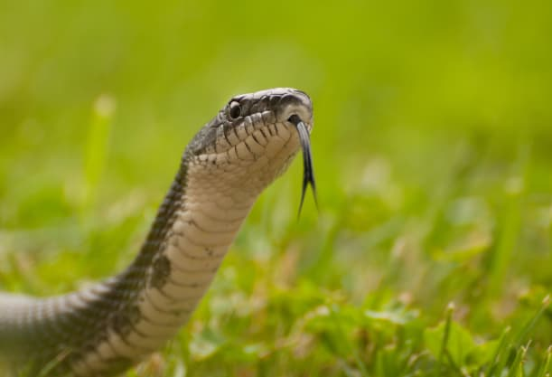 | Snakes have a narrow, forked ____________. They _________ with their tongue by repeatedly flicking it in and out.
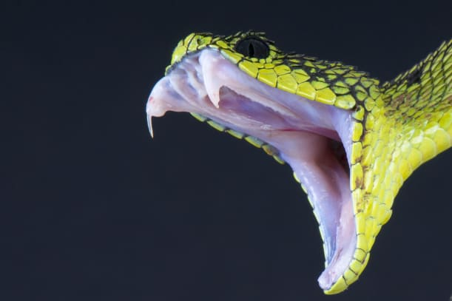 | Some snakes ______ with two pointed teeth called _______.
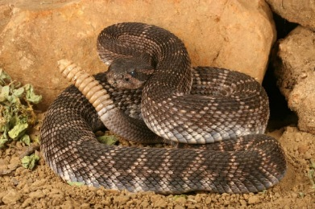 | Many snakes make threatening noises or ________ loudly when an enemy comes near. Rattlesnakes shake the rattle on their _______ when threatened.

