Small Boat
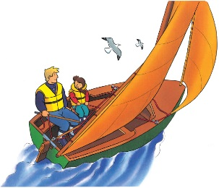 | Floating on the water in a small boat is great fun. You can sit in a _______________ and let the wind blow you gently along. A sailboat often tips and rolls in __________, so remember to hold on tight!
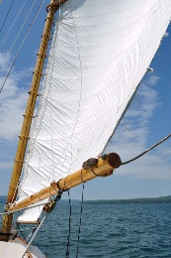 | The wind blows against a large _______ and pushes the boat forward. A tall, strong _______ holds up the sail.
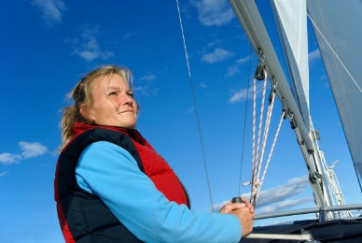 | To move the sail, you pull on a thick __________. A ______ ____________ helps keep you safe if you fall into the water.
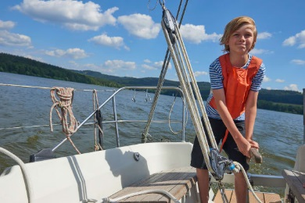 | You move the _____________ to make the sailboat turn.
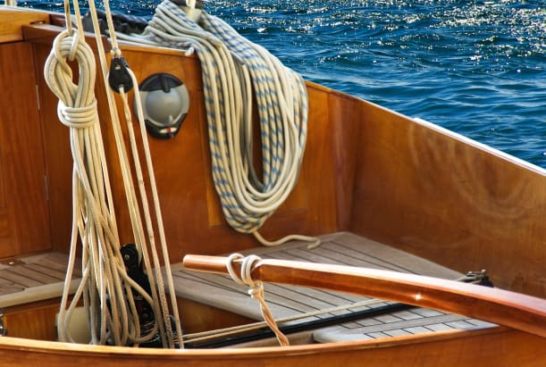 | The ________ floats in the water. There is room for a few people to sit inside. The storage space inside the boat is called a _________.
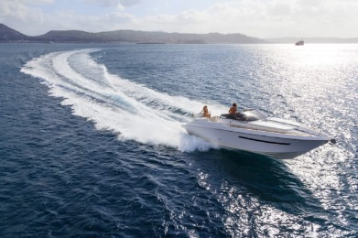 | ________________ have powerful engines and can go extremely _______. Sometimes, when they hit a __________, they jump right out of the water!

