Sloth
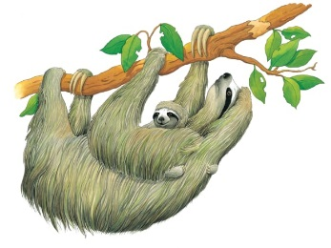 | A sloth spends most of its life hanging upside down, fast ______________. When this strange-looking creature wakes up, it slowly ____________ along its branch, looking for ____________ to eat. About once a week, it creeps down the tree trunk to the ground.
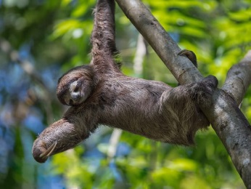 | A sloth hangs upside down from a tree branch with its __________. The sloth hooks its claws tightly over a branch, so that it doesn’t fall.
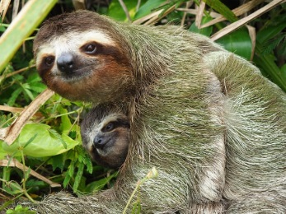 | A sloth hardly ever washes! Green __________ grows on its long fur.
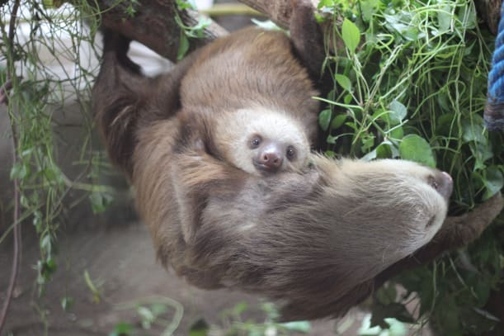 | A _________ sloth clings to its mother’s belly. There, baby is cosy and safe.
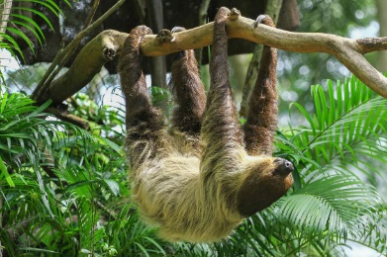 | A sloth ____________ while hanging upside down for up to 18 hours a day. Because it’s hardly ever awake, a sloth doesn’t need to eat much _________.
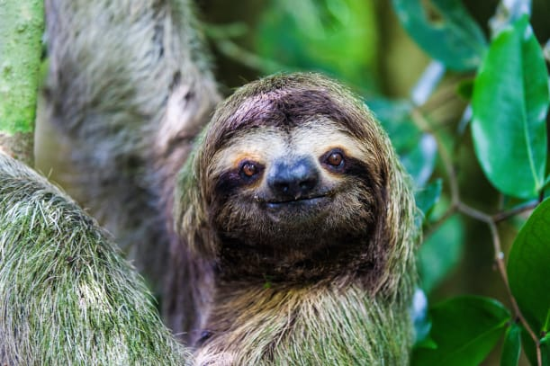 | All sloths have a small _________. They have blunt __________ and peglike teeth.

