Ship
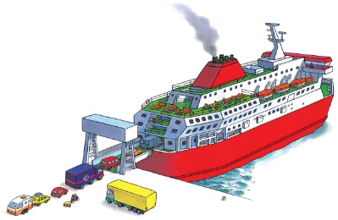 | Ships are giant __________. Many ships cross the big ___________ from one side of the world to the other. __________ carry people on short journeys. One end opens up to let people __________ on board.
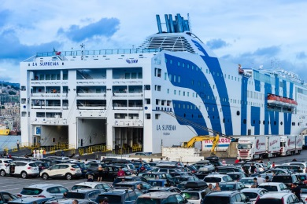 | People wait at the ________ before driving onto the ferry.
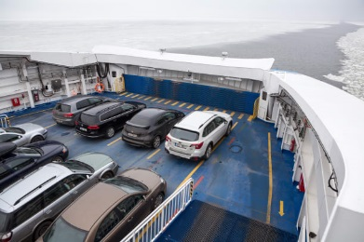 | People park their cars on the ______ ___________.
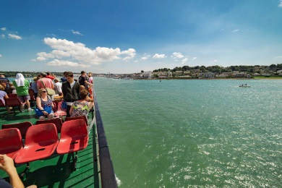 | On the ______ ________, you can sit on seats and chat.
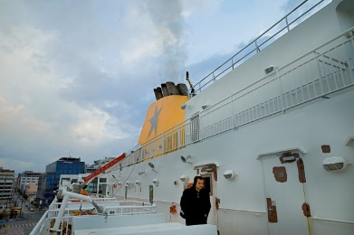 | Smoke puffs out of the __________________.
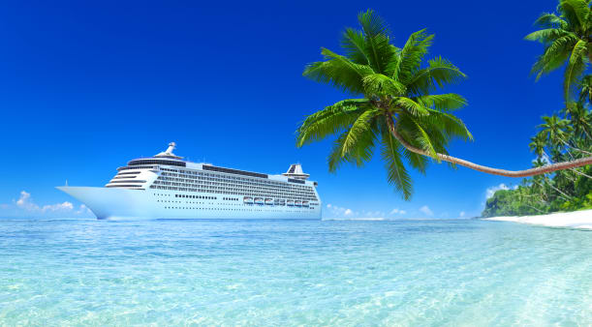 | A ___________ ________ slowly glides through the warm, blue sea. It is taking hundreds of people to a faraway vacation.

