See and Hear
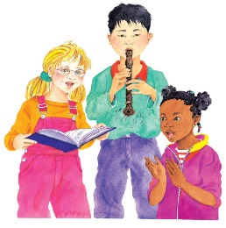 | All day long, you _______ at things around you and _________ all sorts of sounds. You do it without even trying! These children are _______________, singing, and playing ____________.
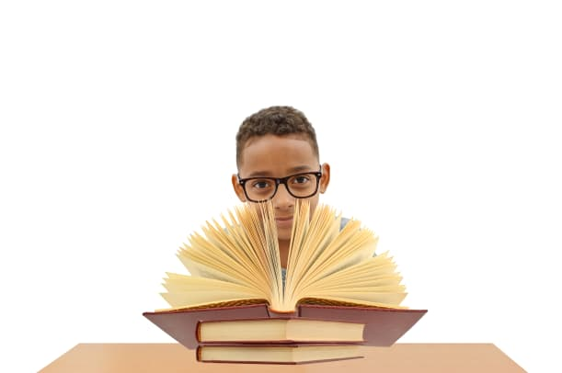 | This boy is wearing _______________________ to help him see more clearly.
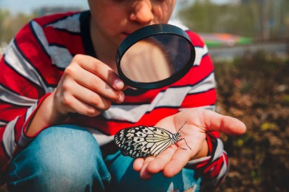 | When you look through a ________________ glass, everything seems really big even the patterns on a butterfly’s _____________.
 | This mother and daughter are talking with their ___________. The girl can’t hear words so they make special ___________ that stand for ideas.
What are some of your favourite sounds? | _______________________________________  _______________________________________  _______________________________________  _______________________________________

