Scientists
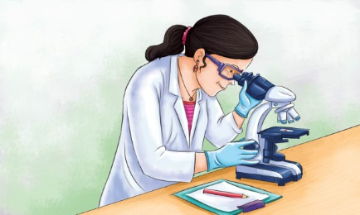 | Scientists study ______ and how things happen. They try to learn about the world, especially about __________. Scientists study many different subjects. Some scientists study how __________ and animals live and grow. Some study __________. Others study the _______________ and the things in it.
 | This scientist works in a _____________________, a special place to do scientific experiments and investigations. A clean lab _________ protects against spill sin the lab.
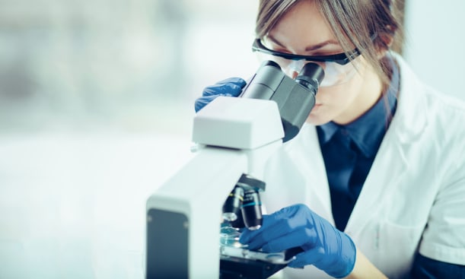 | A __________________________ makes tiny things look bigger. Special glasses called ______________ keep scientists’ eyes safe in the lab.
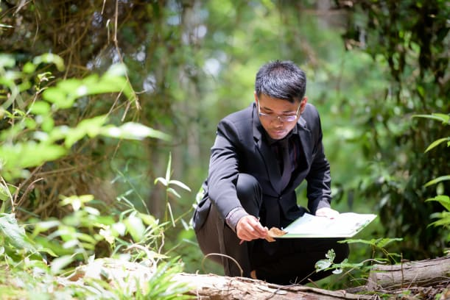 | A scientist who studies living things is called a ___________________.
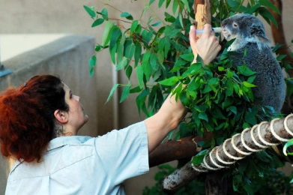 | ________________________ study how animals live. The zoologists learn what can __________ or hurt animals.

