Plumber
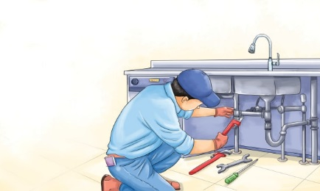 | Plumbers help us get clean and stay warm in many ways. A plumber puts in or fixes _________ that carry water into and out of buildings. Plumbers put in and fix sinks, ____________, bathtubs, boilers, and showers. They stop leaks and unclog __________. Plumbers also connect _______________________ and washing machines to the water pipes in a house.
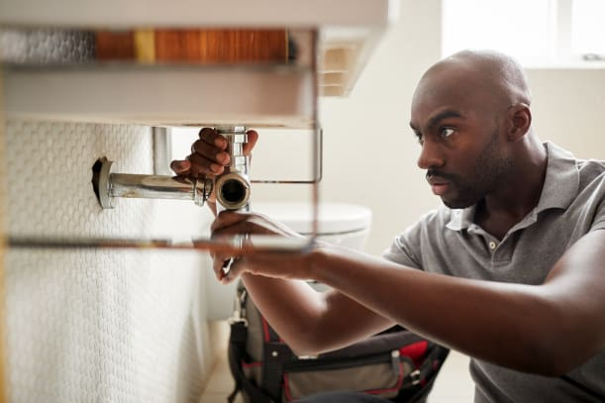 | The plumber works on pipes below the __________.
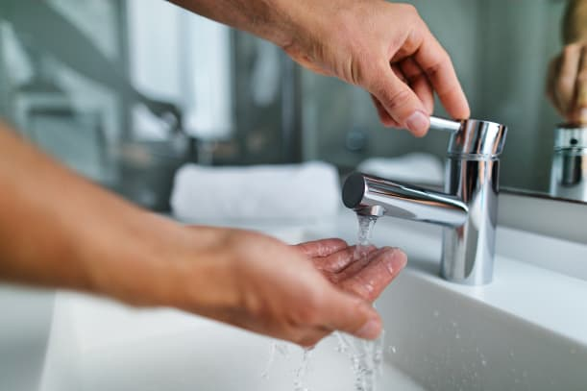 | When people turn on a ____________, a valve opens and lets the water flow in.
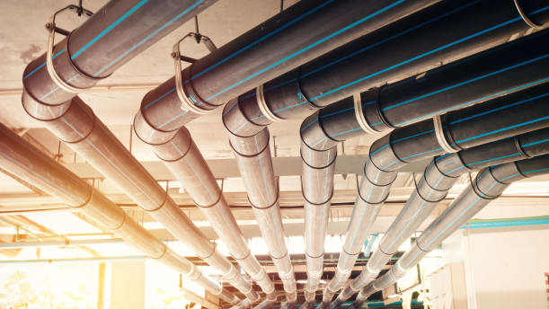 | A _________ carries water into and out of a building.
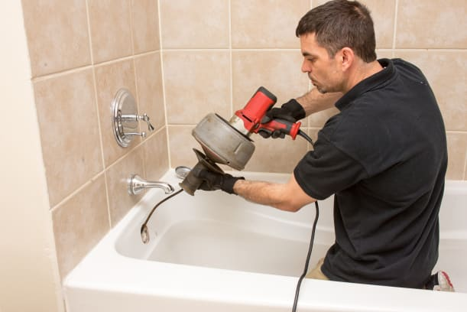 | A plumber uses a special tool to unclog a ___________.

