Parts of the Body
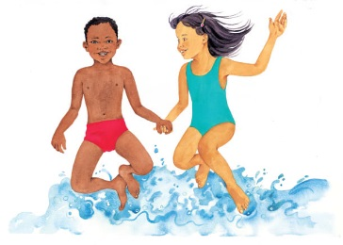 | Your body is amazing! It’s made up of a lot of different parts inside a stretchy covering of _________. Girls and boys look different from each other, but their bodies work in the same ways.
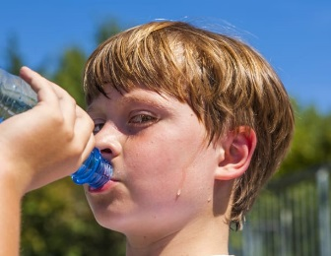 | Your body is mostly __________. When you’re hot, you ___________ water through your __________.
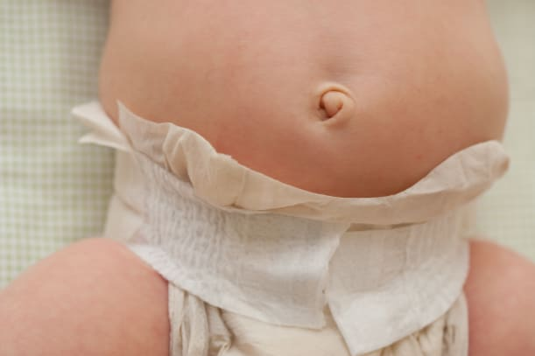 | Your _________________________ is the place where there was a special ________ that you needed as you grew in your mother’s body. When you were born, the tube was ______ and tied, leaving your bellybutton.
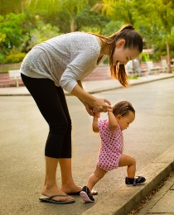 | A baby holds her mother’s hands while learning how to _________. Soon she will be able to walk on her own.
Can you name the main parts of the body? | ________________________________________  ________________________________________  ________________________________________  ________________________________________  ________________________________________

