Palm Trees
 | Palm trees grow in _________ parts of the world. They can be found in _____________ and tropical islands. The tree has a long, slender ___________. The trunk ends In a crown of huge _____________. The leaves are shaped like feathers or ____________.
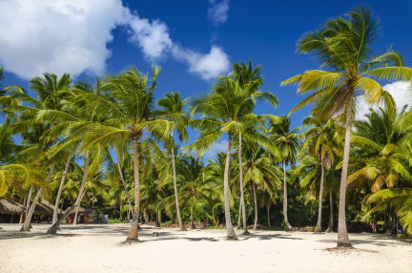 | A palm tree has a long, slender __________. Most palm trees have no ___________________.
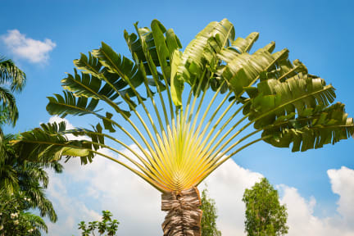 | Huge leaves spread out in a ________________ at the top of the palm tree. The leaves are shaped like fans or _____________________.
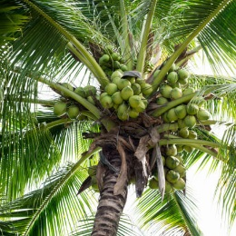 | Bunches of large, round ________________ grow among the leaves. Coconuts are the ______________ of the coconut palm.
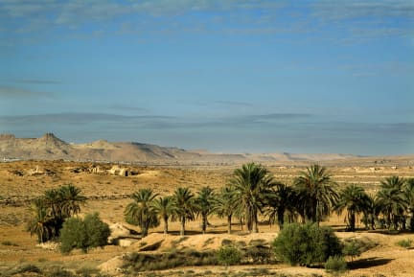 | The ___________ palm is an important fruit tree in the Middle East. It grows in the _______________ where few plants live.
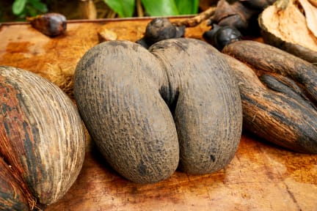 | The largest __________ in the world are the nuts of the _____________ ______________palm. This palm grows in the Seyschelles, a group of islands in the _______________ Ocean.

