My Face
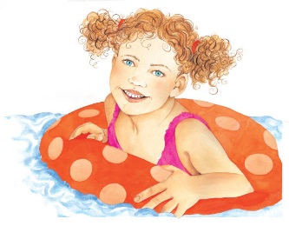 | Everyone’s face is different! Your face is the part of your body that shows people how you _________ inside. ________________ can mean you are feeling sad. Smiling shows everyone that you are ___________.
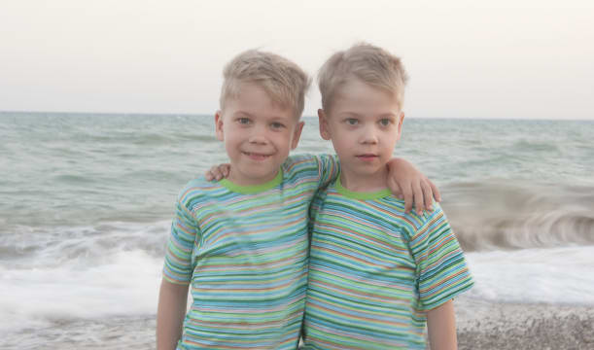 | These brothers are identical __________. They are born to the same ________________ at the same time and look almost exactly the same as each other.
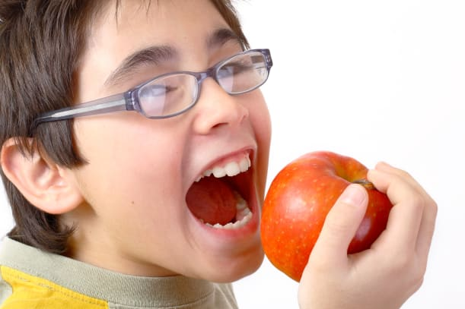 | Strong, rock-hard ____________ are for biting and _____________ food. They also make nice __________!
 | Your __________ tells you if a smell is nice or ___________.
Draw your own face or that of a friend or loved one.

Who did you draw?

__________________________________

